|  |  |
| --- | --- |
| Organizational Unit | Group Policy |
| IT | deny access to registry & task manager |
| Sales | Deny access to CMD and control panel user  settings |
| HR | Deny access to registry and control panel |
| Domain | Domain password policy is user account should lock after 3 wrong user attempts. After 15 mins user account should be unlocked |

1. Apply below mentioned group polices result screenshot is must

Note: Verify the Output and submit screenshots of the Output

Ans:- Step 1, Created OU’s and Users in Active Directory Users and Computer’s

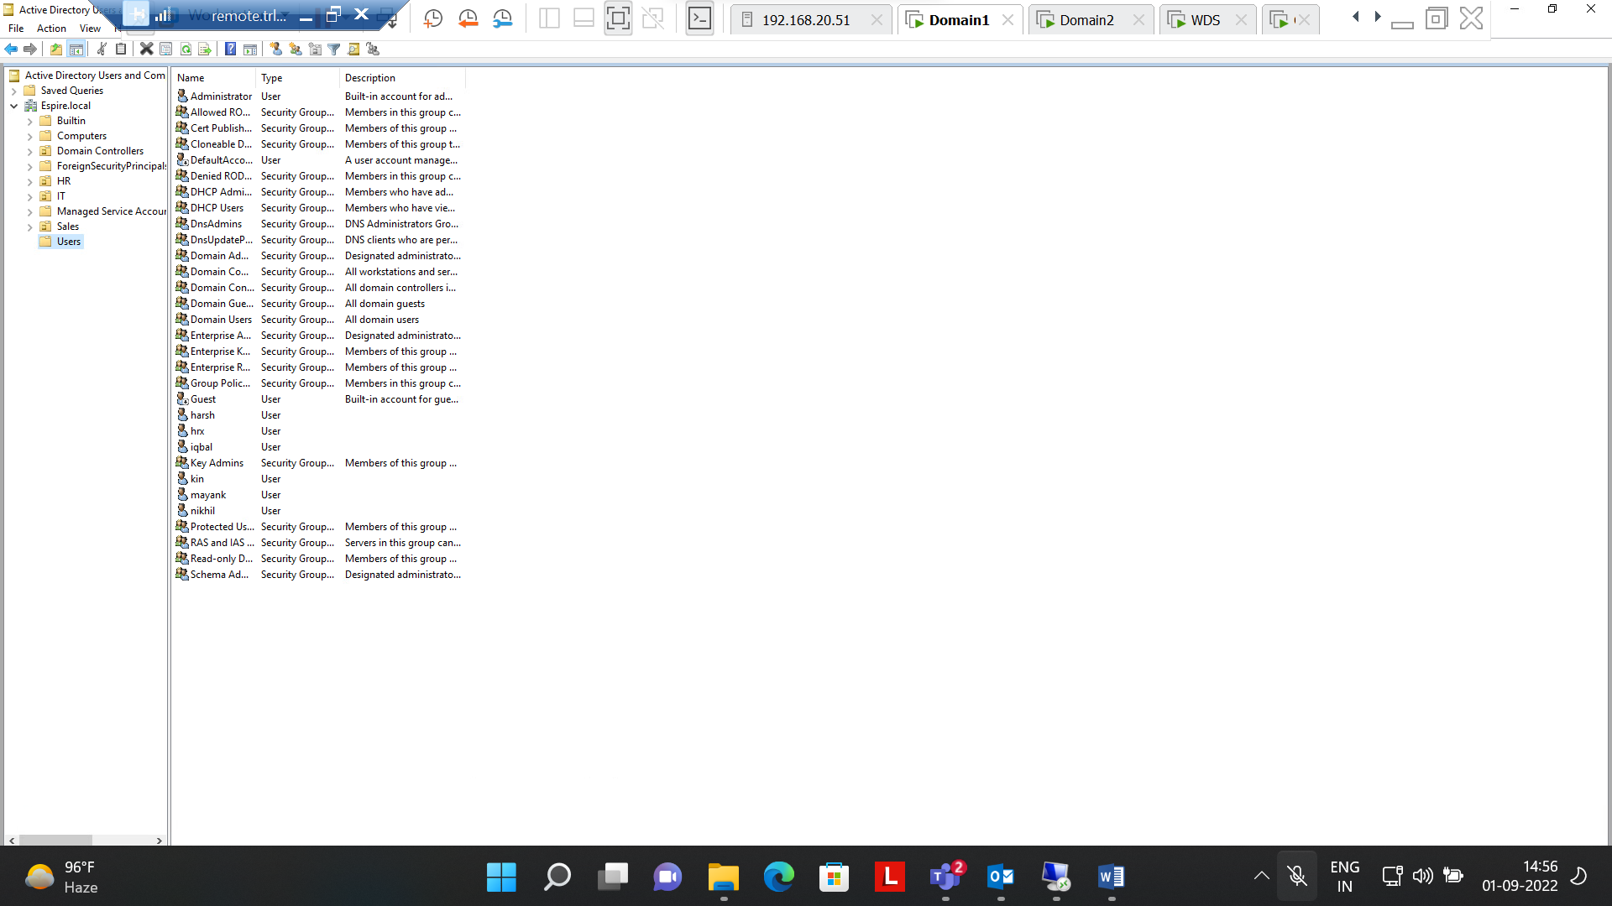

Step 2 :- Enabled Deny access to Task manager

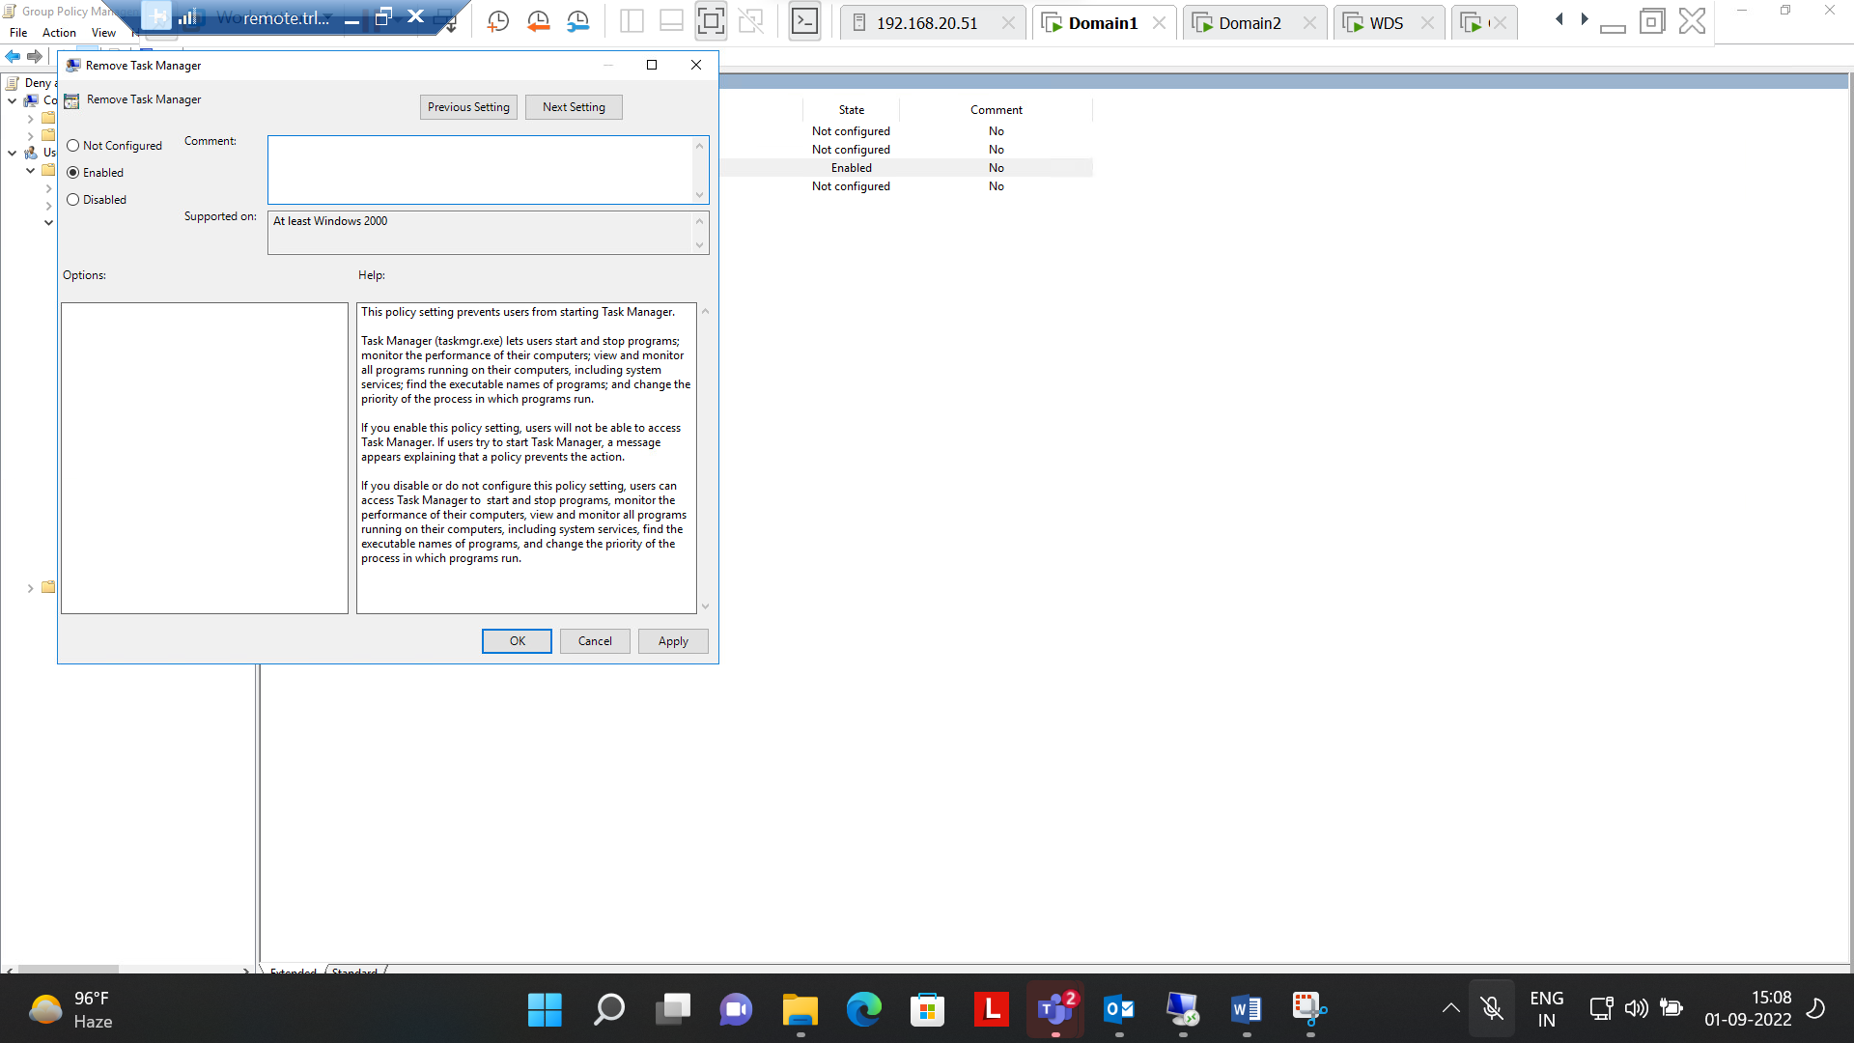

Step 3:- Enabled Deny access to registry

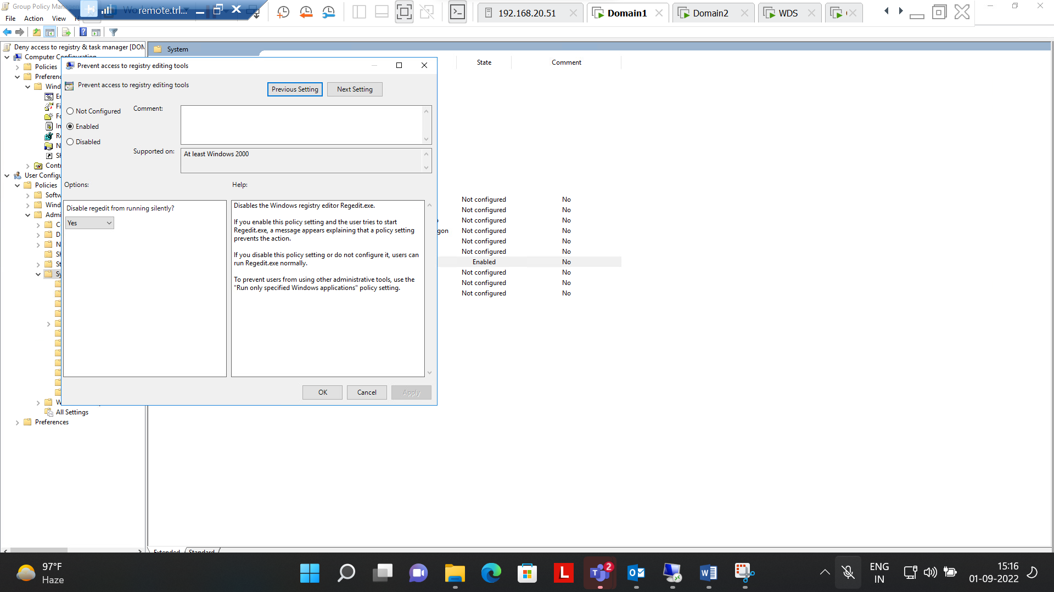

Step 4:- Enabled Deny access to registry & Task manager in **IT(OU)**

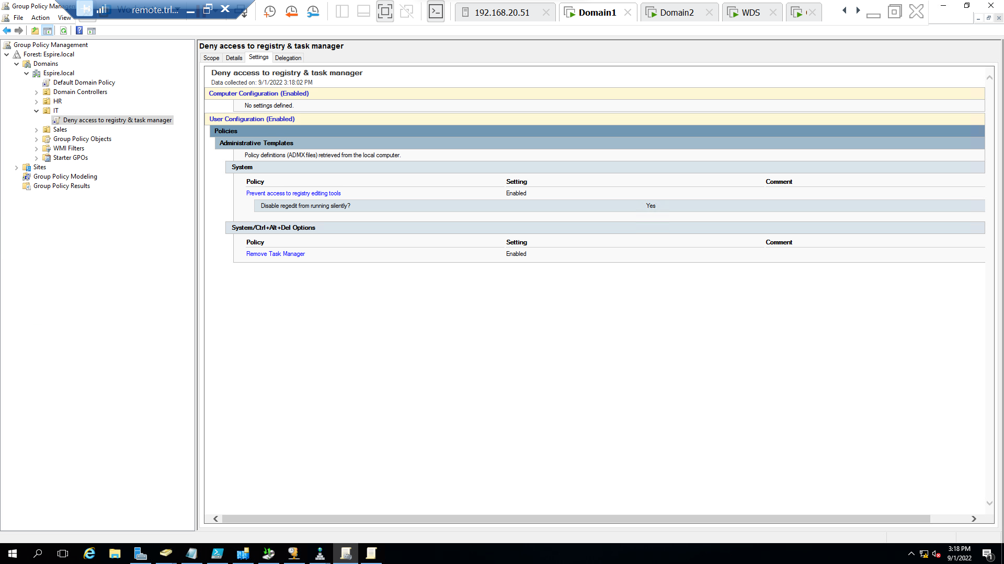

Step 5:- Successfully enabled deny access to Registry and Task Manager on IT user(Checked on Client machine)

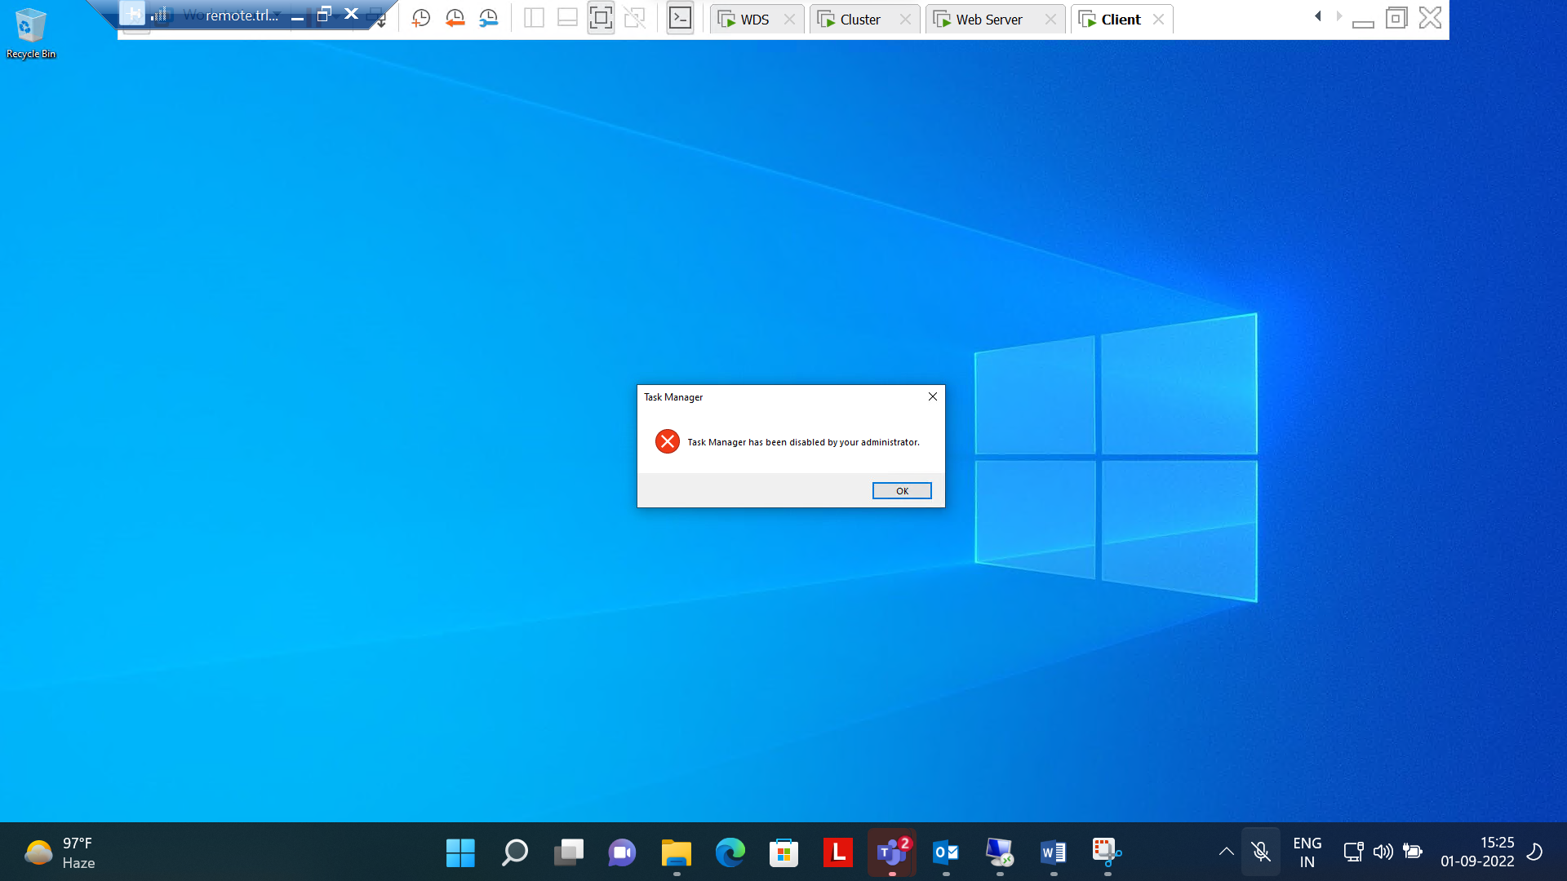

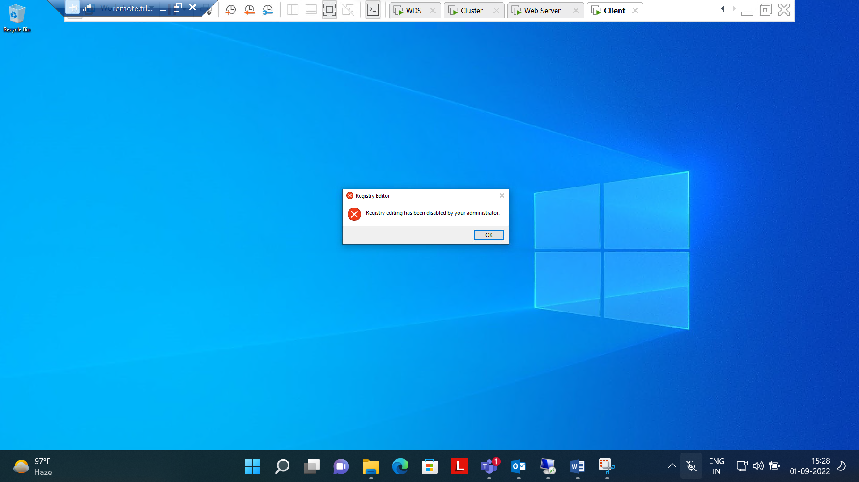

Step 6:- Enabled Deny Access to CMD

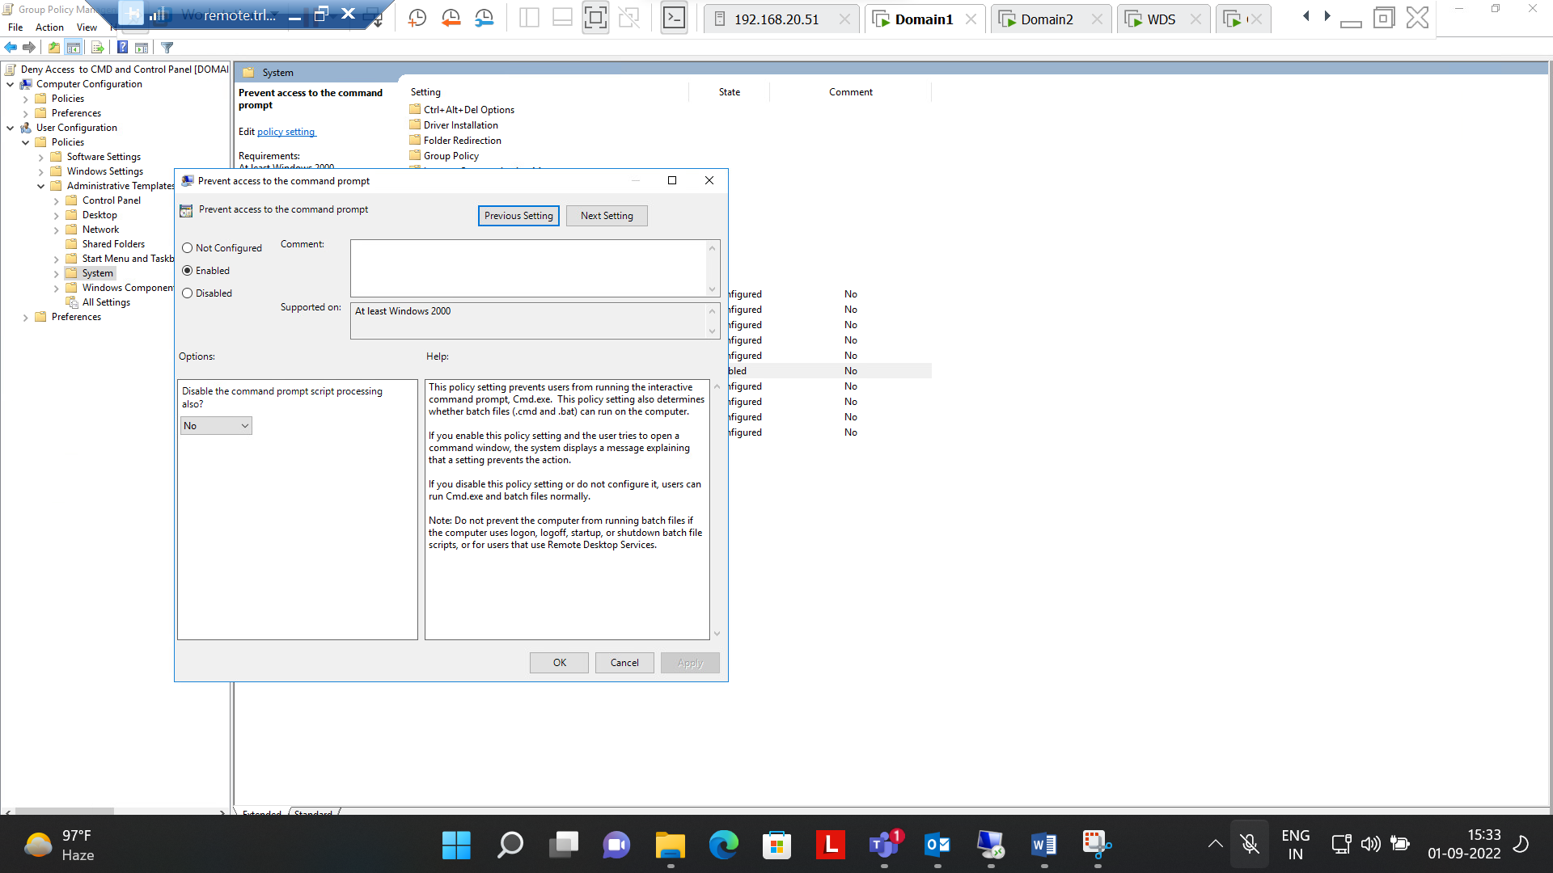

Step 7:- Enabled deny access to Control panel

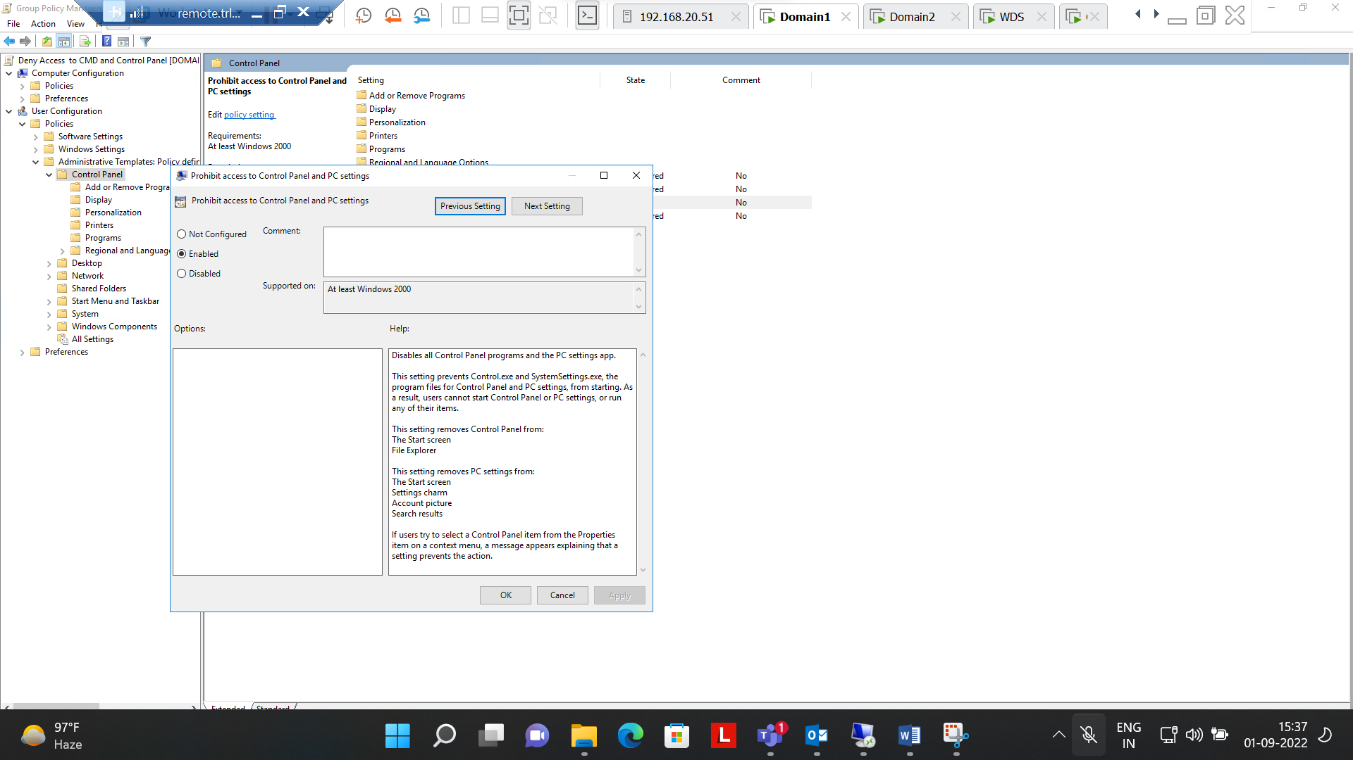

Step 8:- Enabled deny access to Control panel & Cmd In **Sales(OU)**

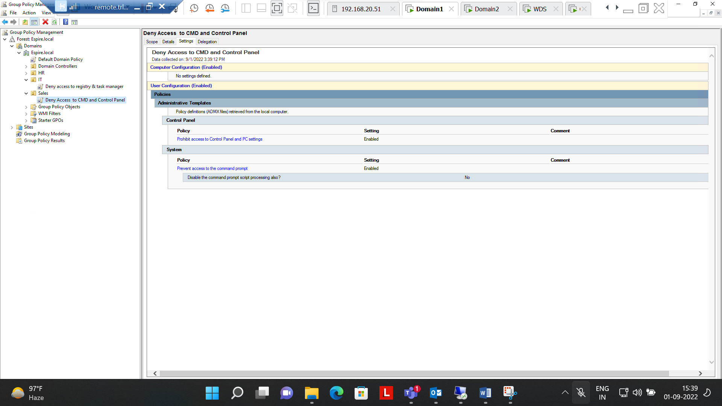

Step 9:- Successfully Enabled Deny access to cmd and Control panel (Checked with sales on user on client machine)

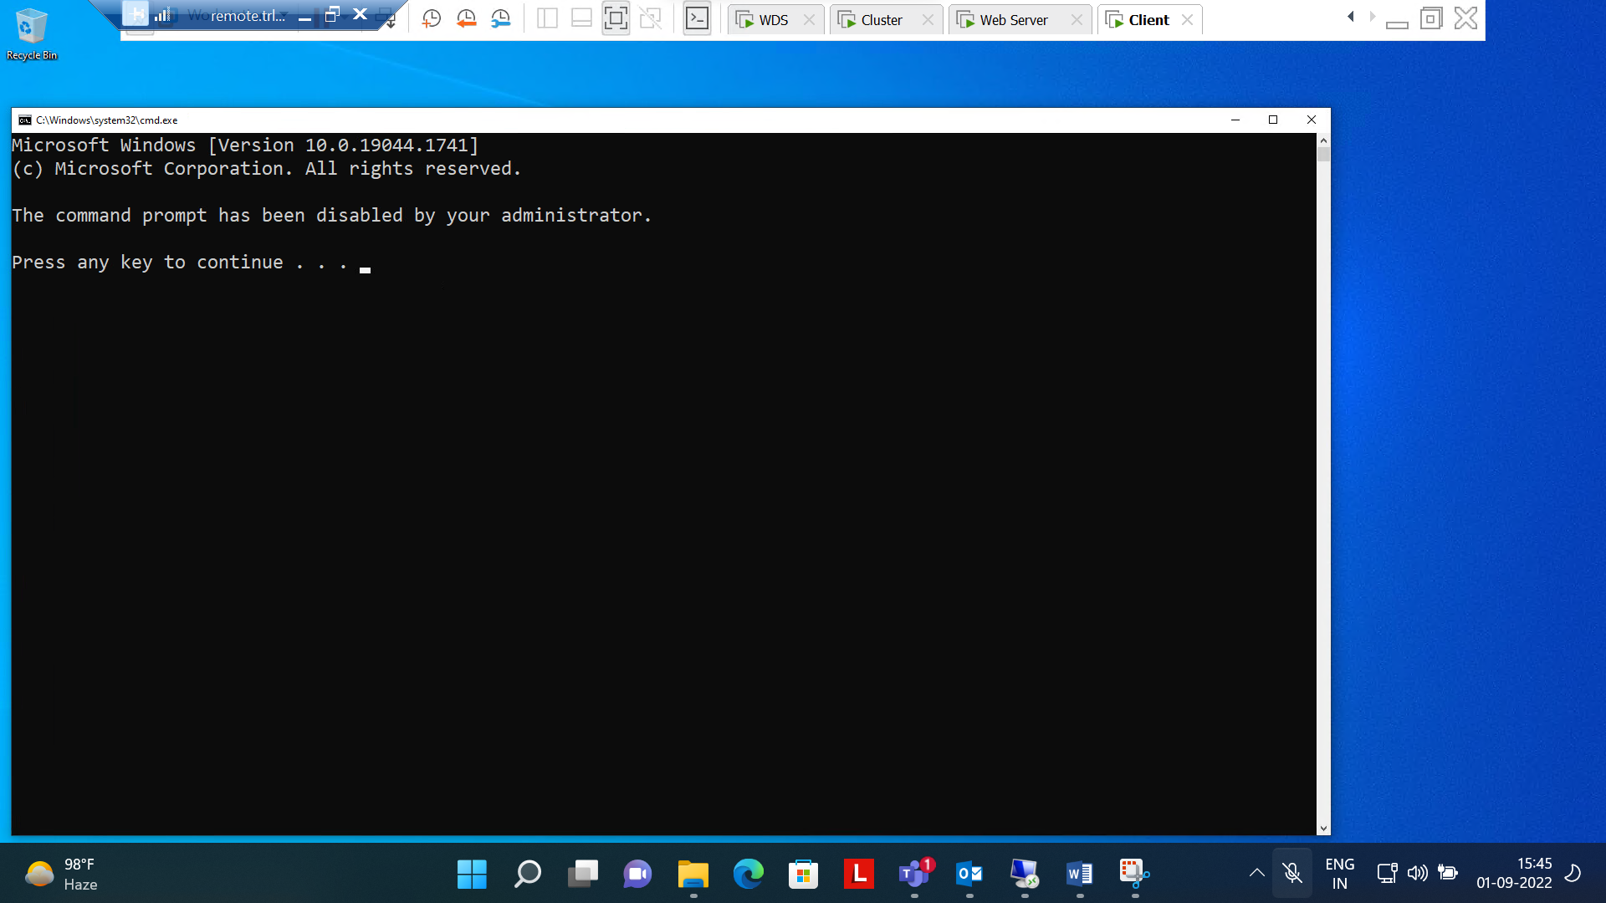

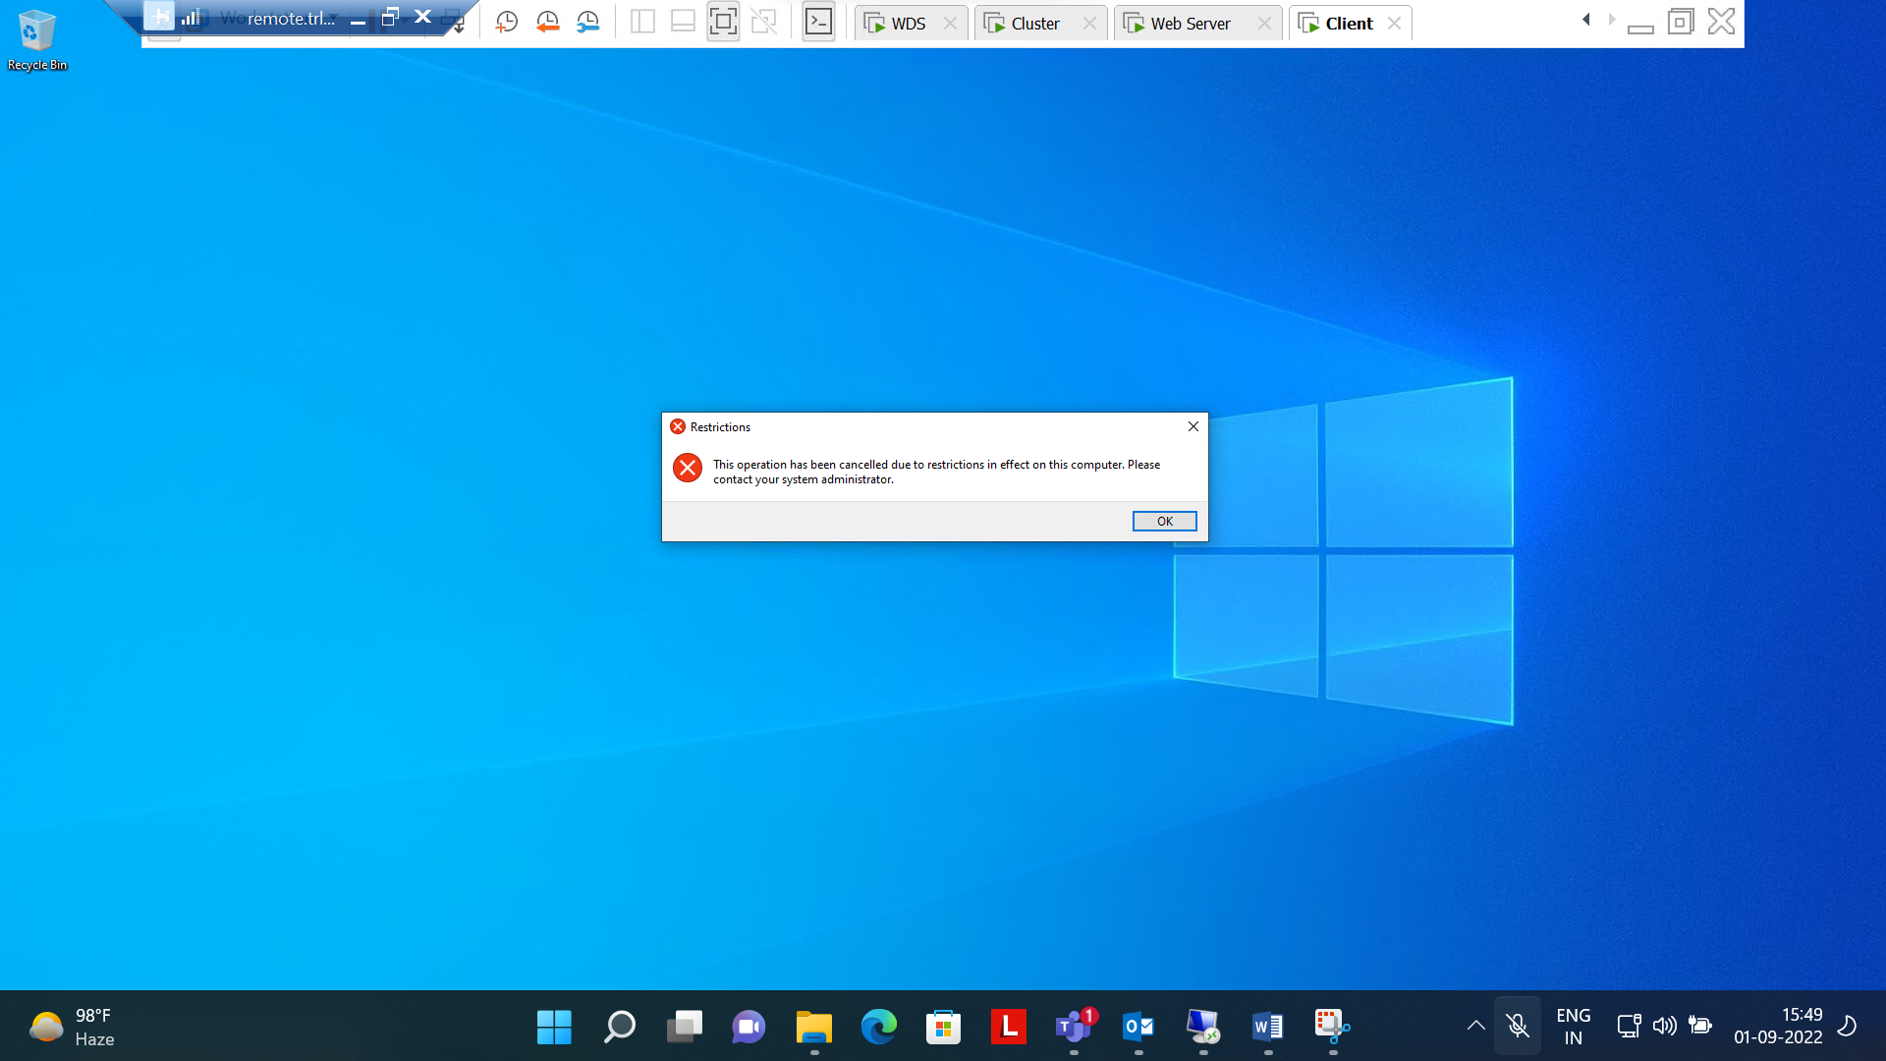

10 :- Enabled deny access to Control panel & Registry In **HR(OU)**

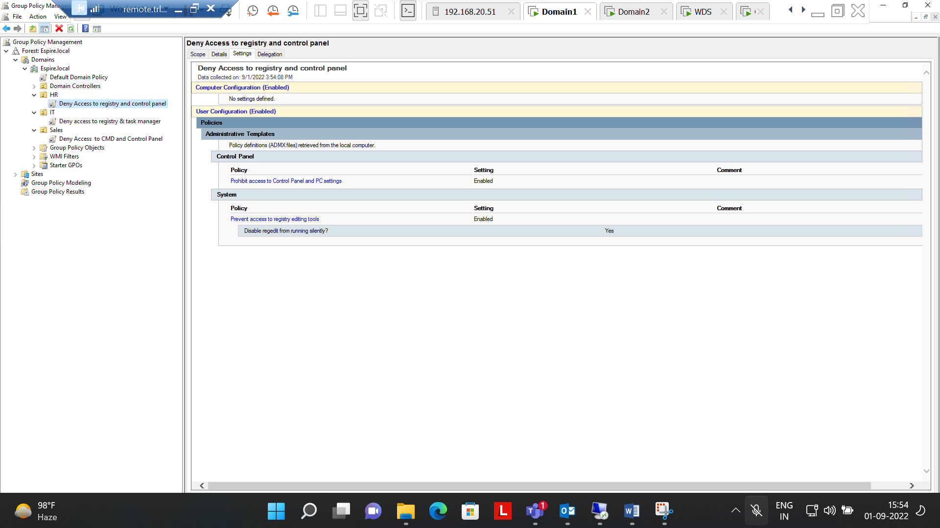

Step 11:- Successfully Enabled Deny access to Control panel & Registry (Checked with HR user on client machine)

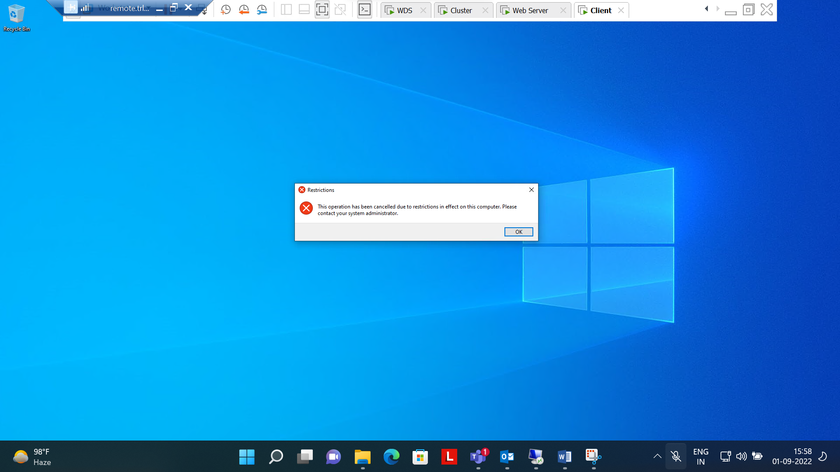

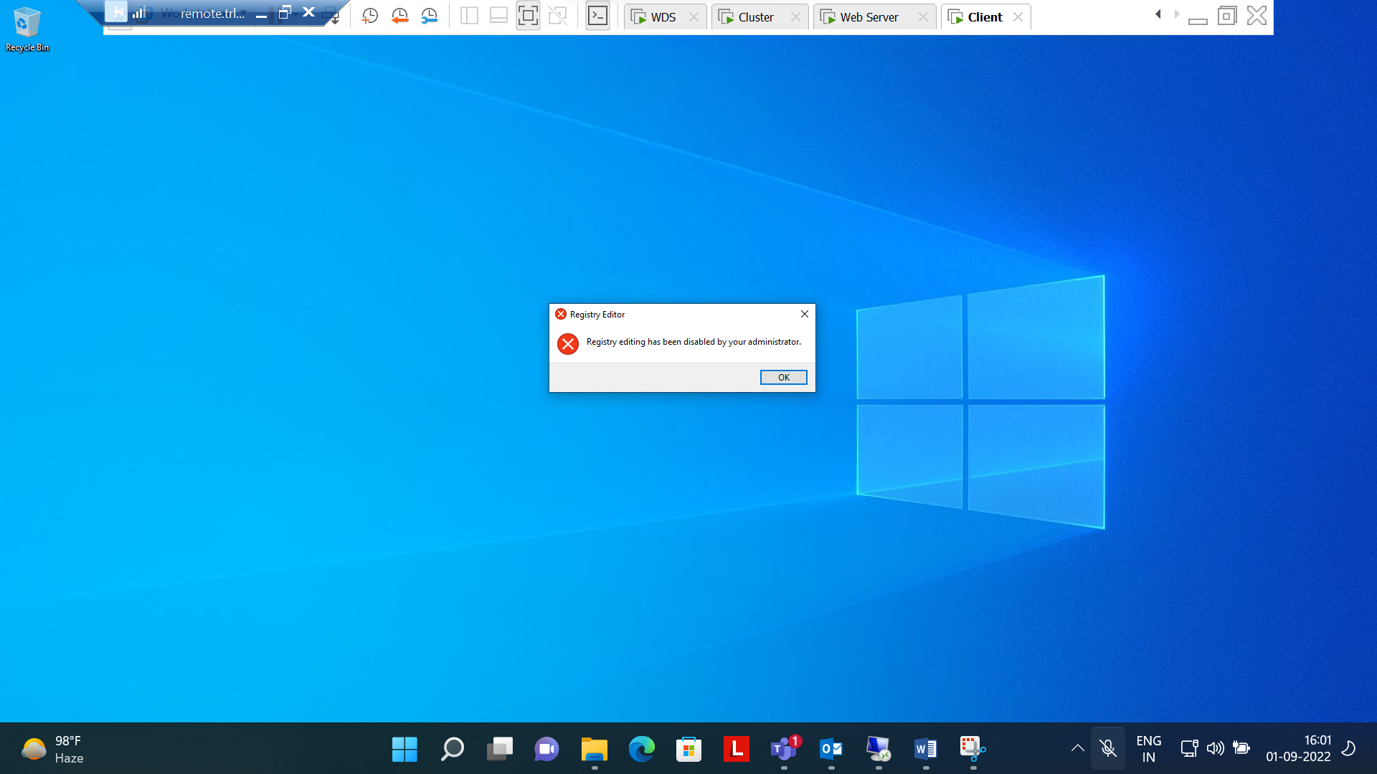

Step 12:- Applied Domain password policy is user account should lock after 3 wrong user attempts. After 15 mins user account should be unlocked

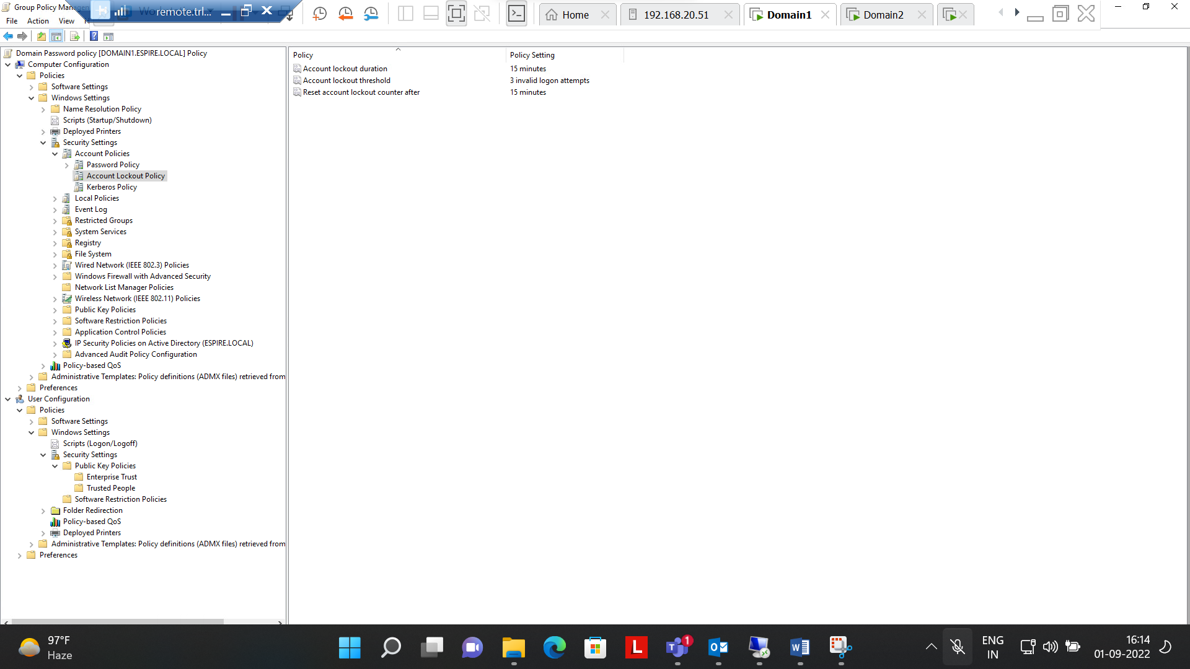

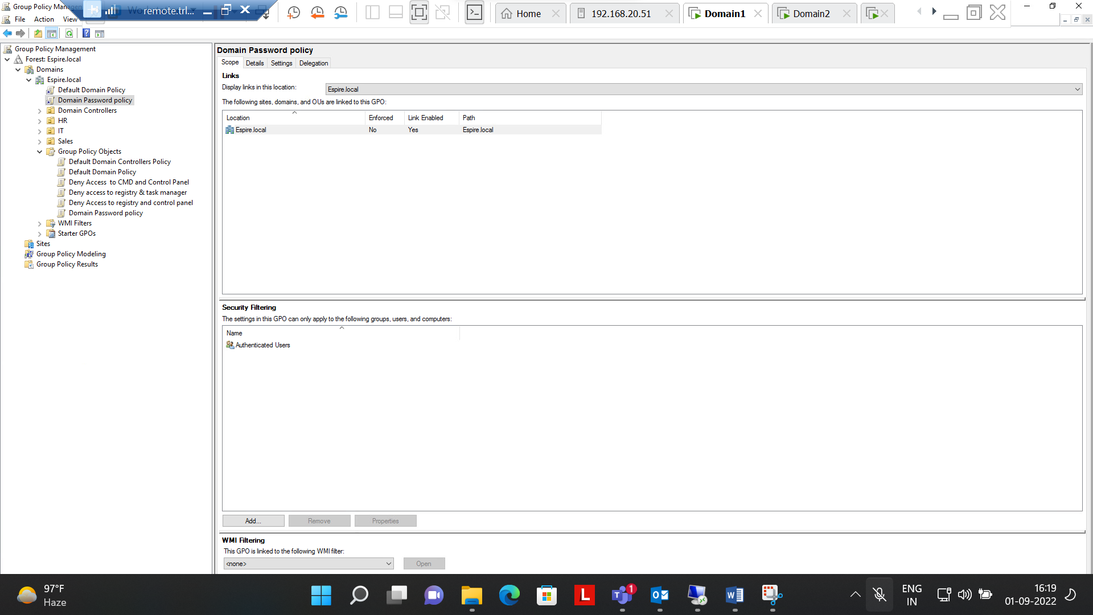

**Question Number 1 is completed successfully**

1. .Apply below mentioned configuration using FSRM. Create a folder for IT as mentioned below. Implement and apply the following FSRM Policy.

|  |  |
| --- | --- |
| Folder | FSRM policy |
| IT | 10 MB hard Quota, can’t save  mp4 files |

Ans :-

Step 1 :- Created a new folder name **IT** in C drive

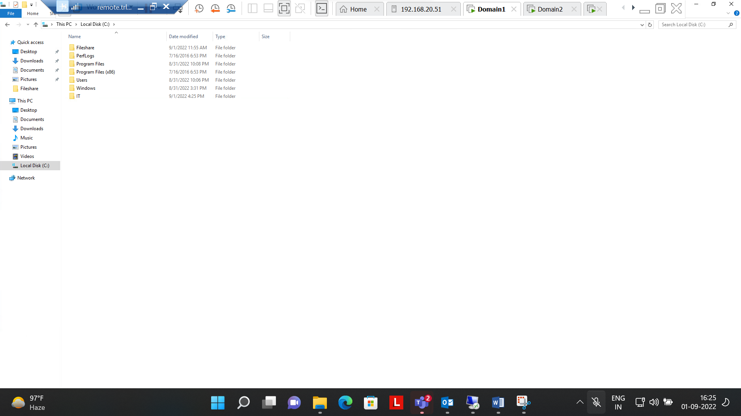

Step 2 :- Created quota template & Applied file Screening(Audio & Video) on IT folder in File server resource manager.

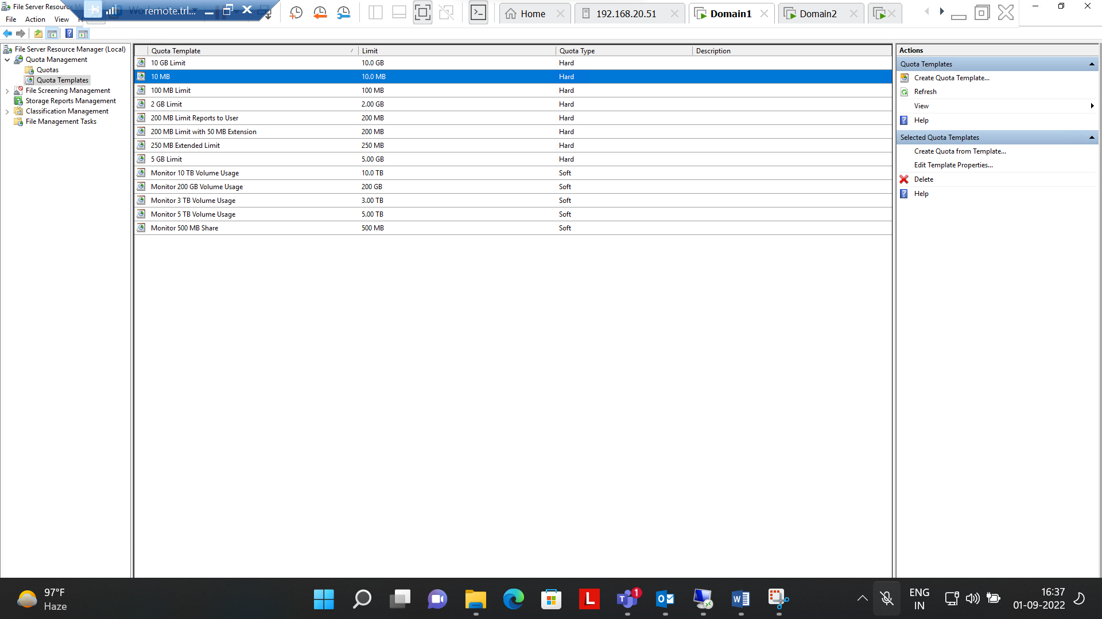

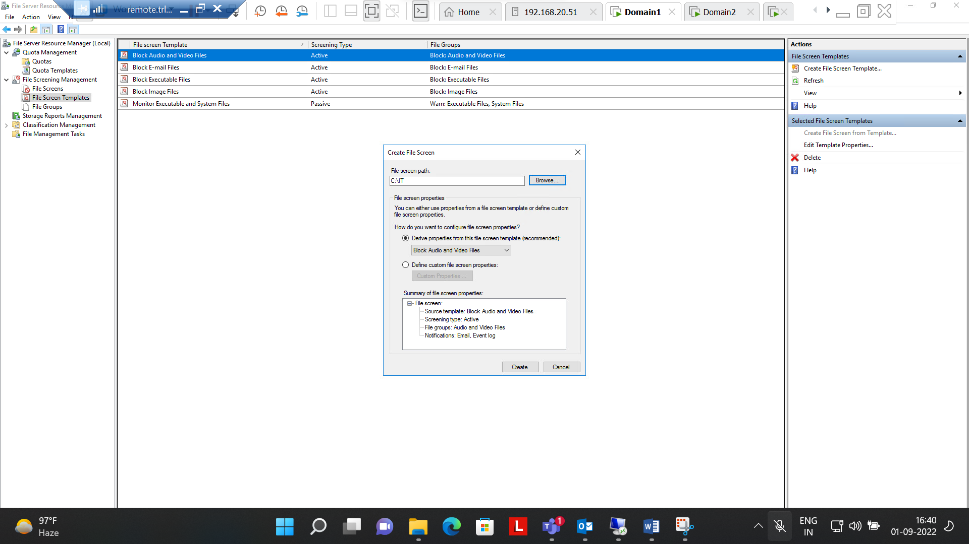

Step 3:- Successfully applied File Screening template (Audio and video) i.e. cant save Mp4 file IT folder.

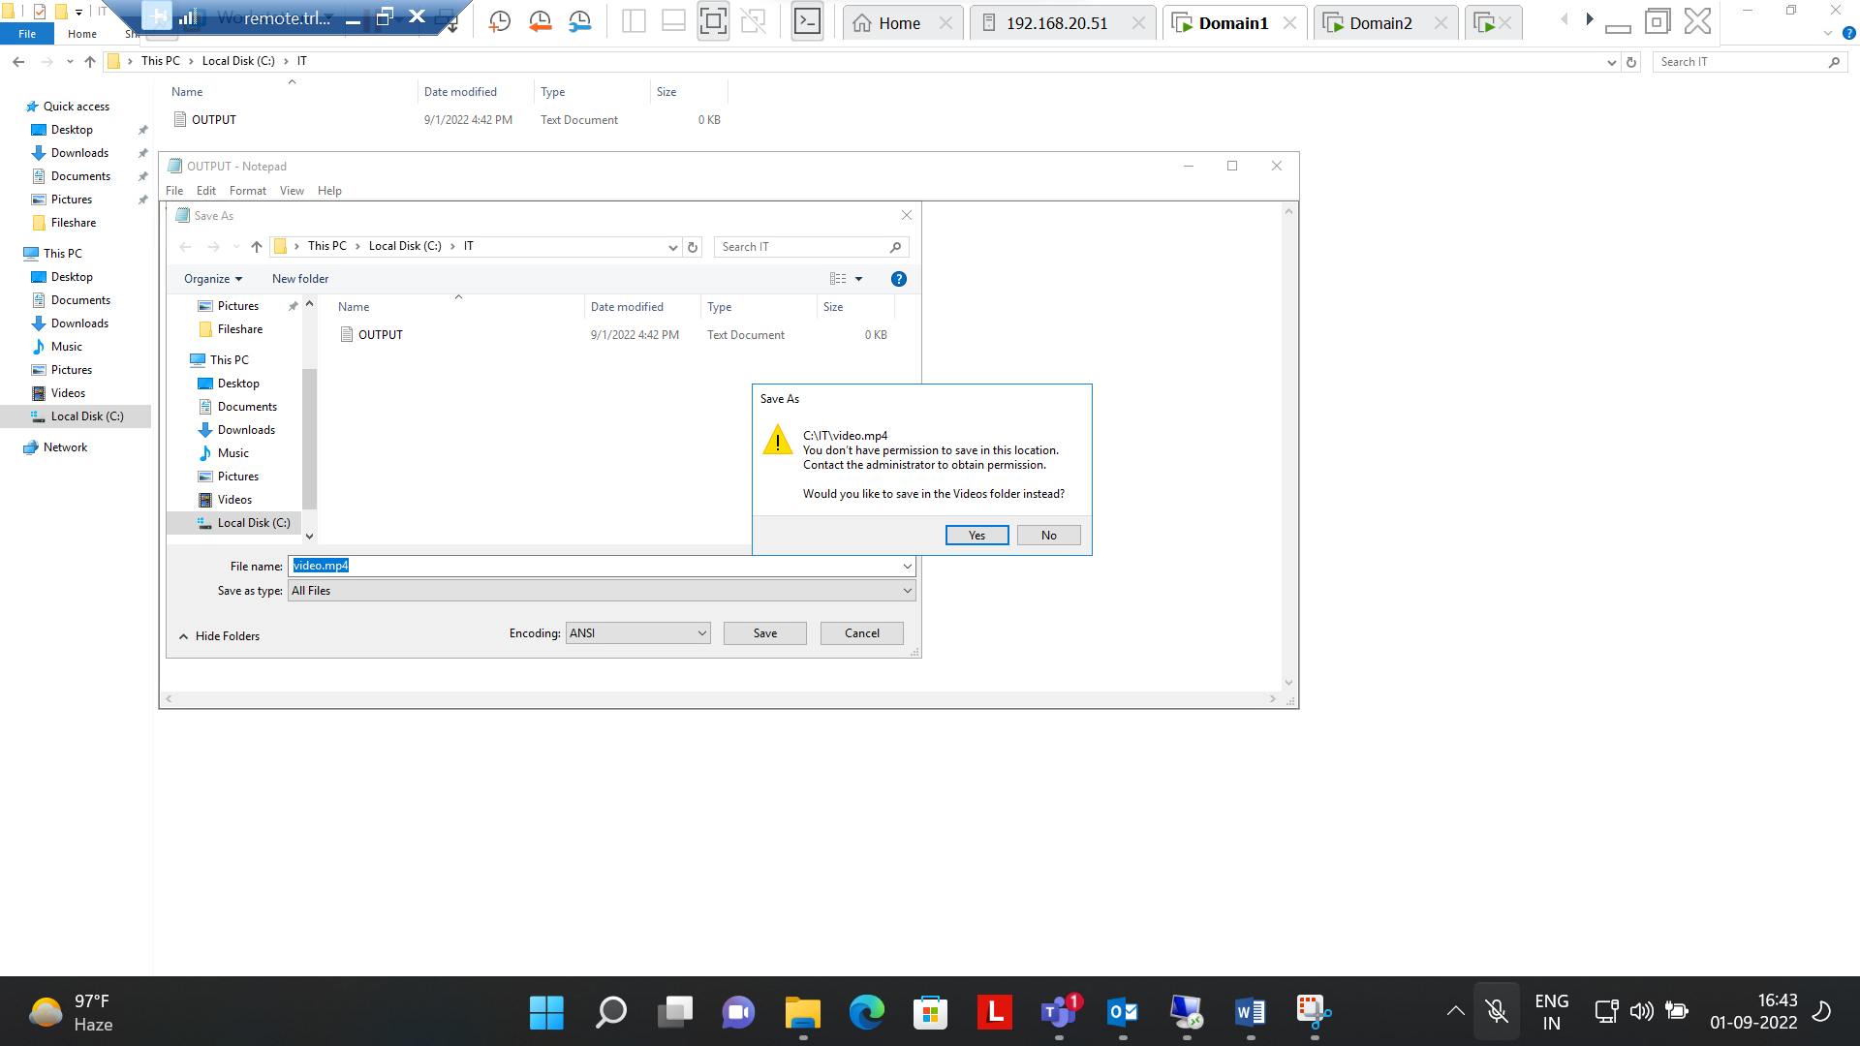

Step 4:- Created Quota for IT folder With maximum size of 10mb & also Successfully applied on IT folder.

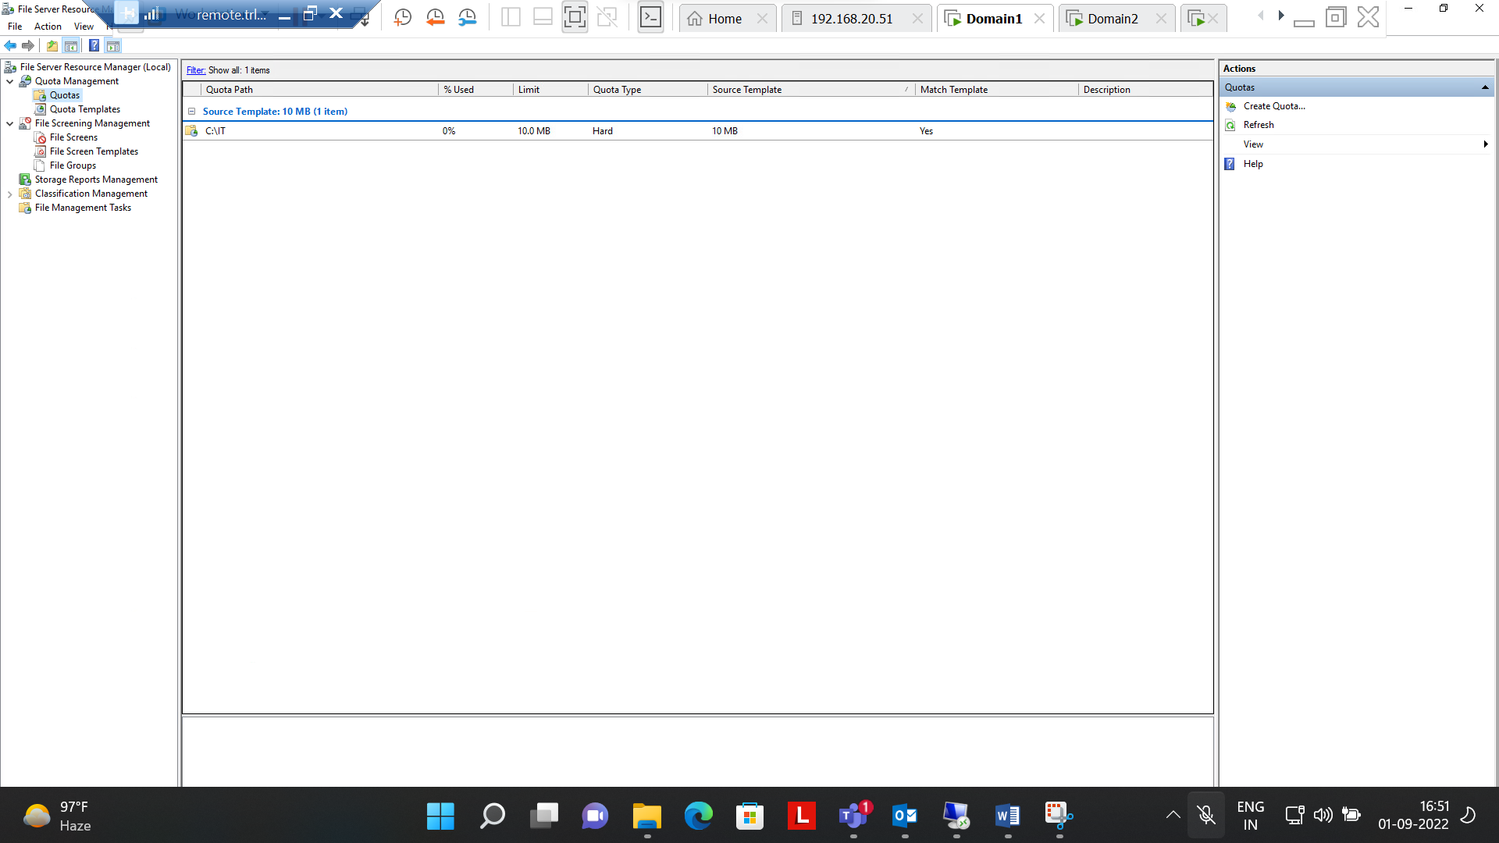

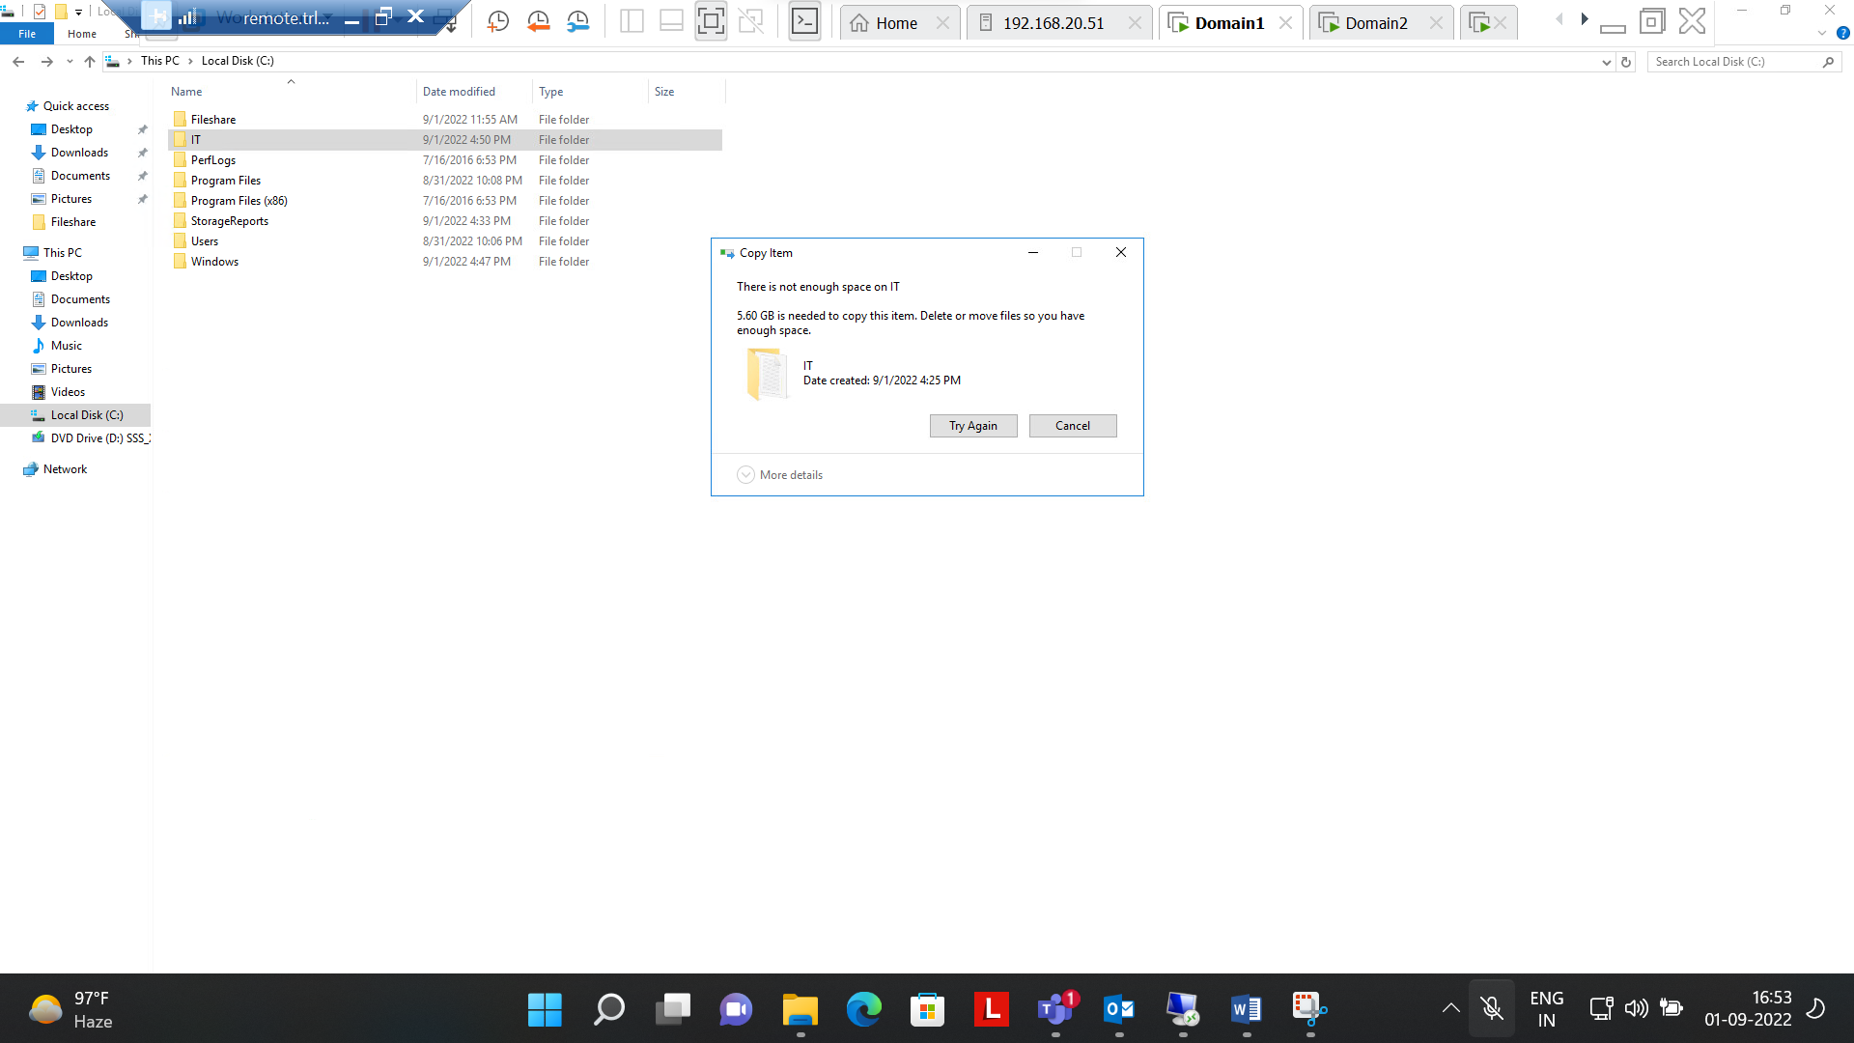

**Question Number 2 is completed successfully**

**Q.3.Perform Backup of a Server Folder into a shared folder in your Client Machine. Delete your server folder and Recover the folder from that backup**

**Ans:-**

**Step 1:-** Created Backup Schedule once in a day using shared folder in domain 2

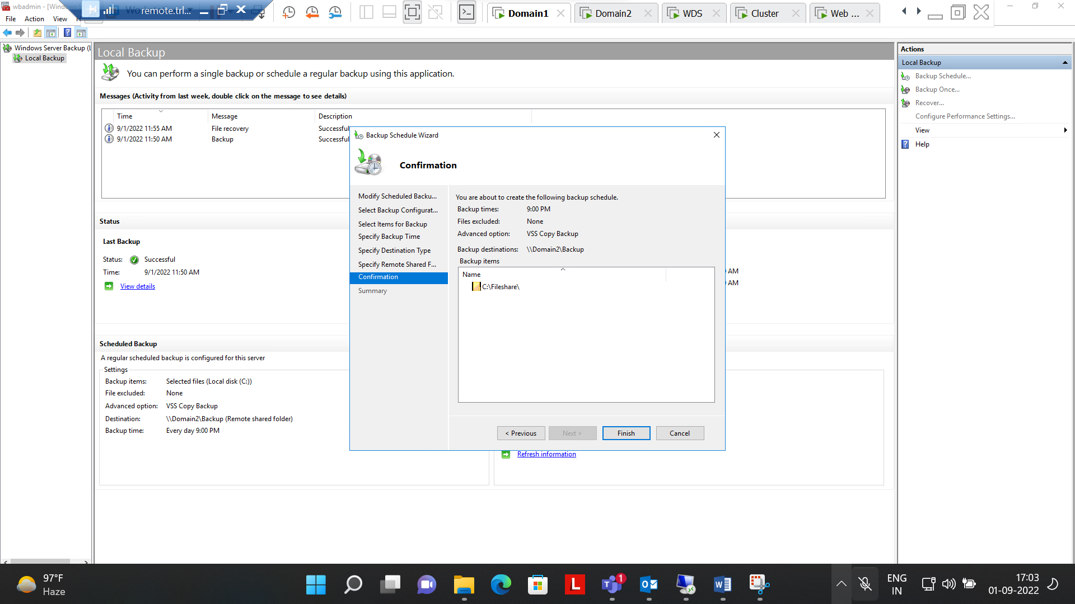

**Step2:-** Created Backup once(Immediate) in shared folder i.e. Backup(folder name)

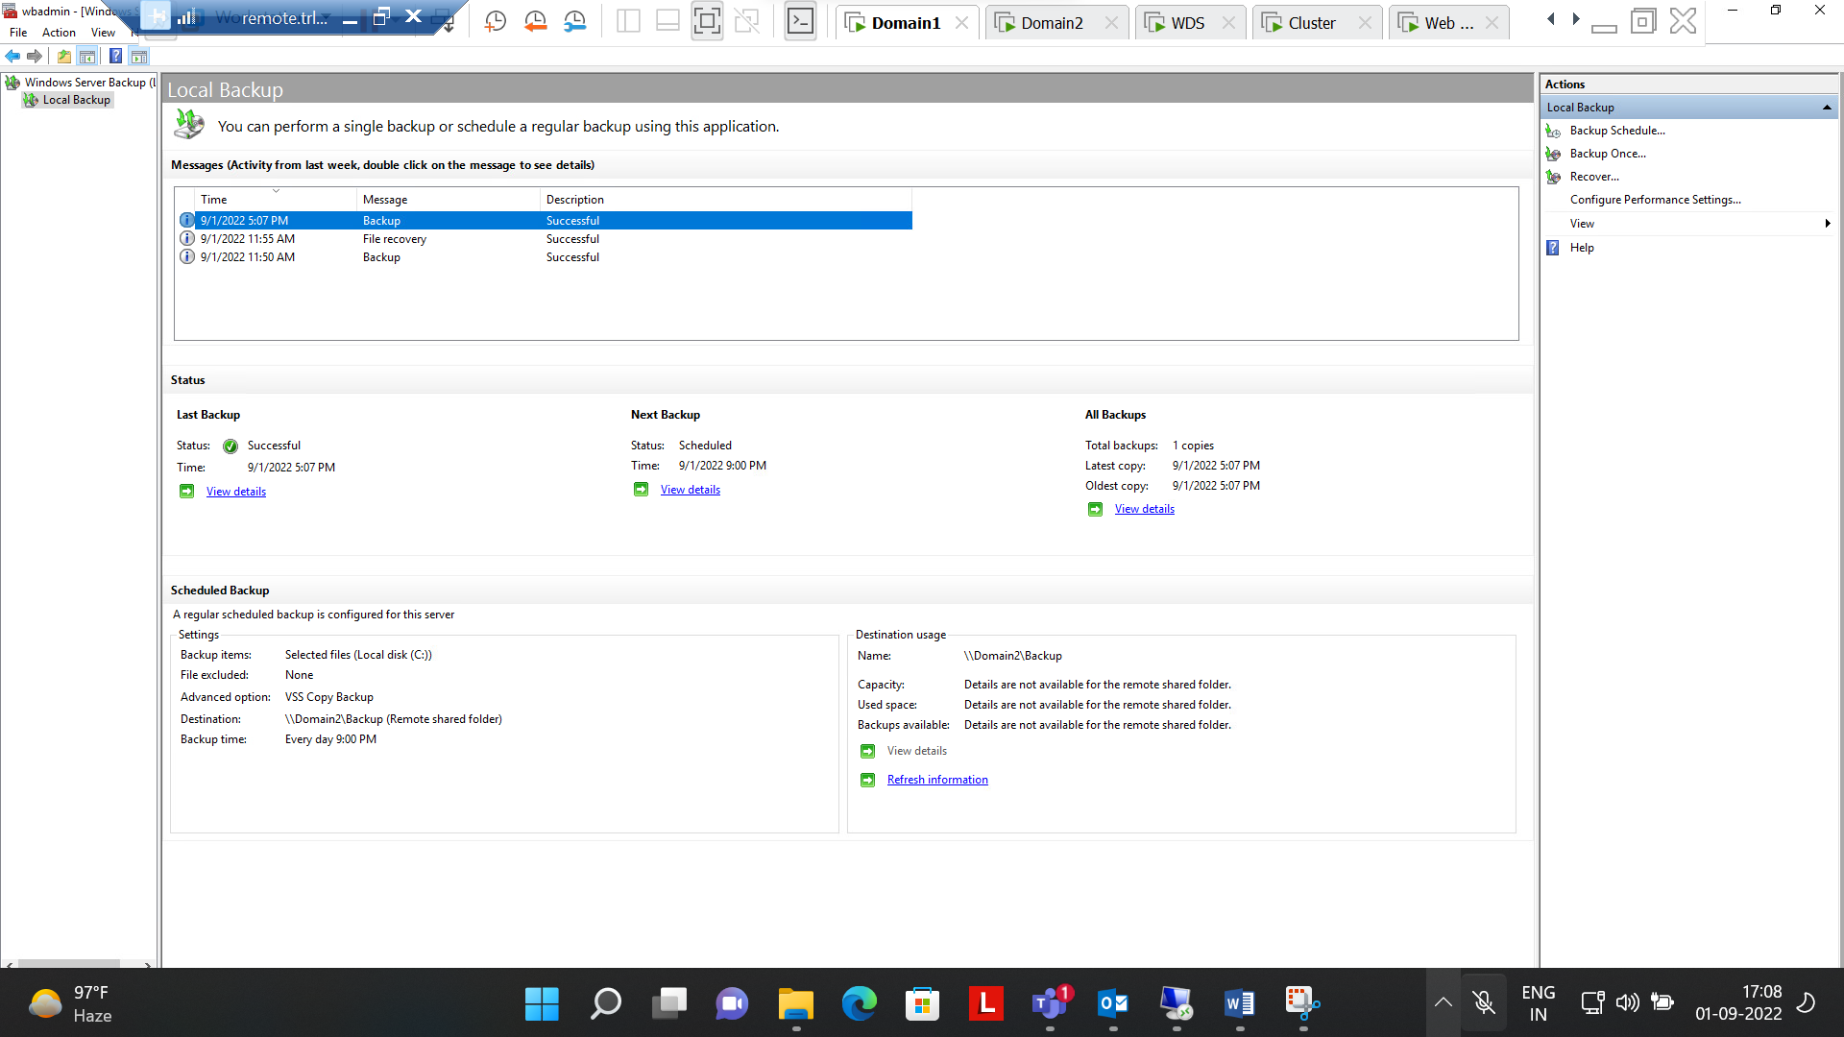

**Step 3 :-** Deleted Files from fileshare in Domain1

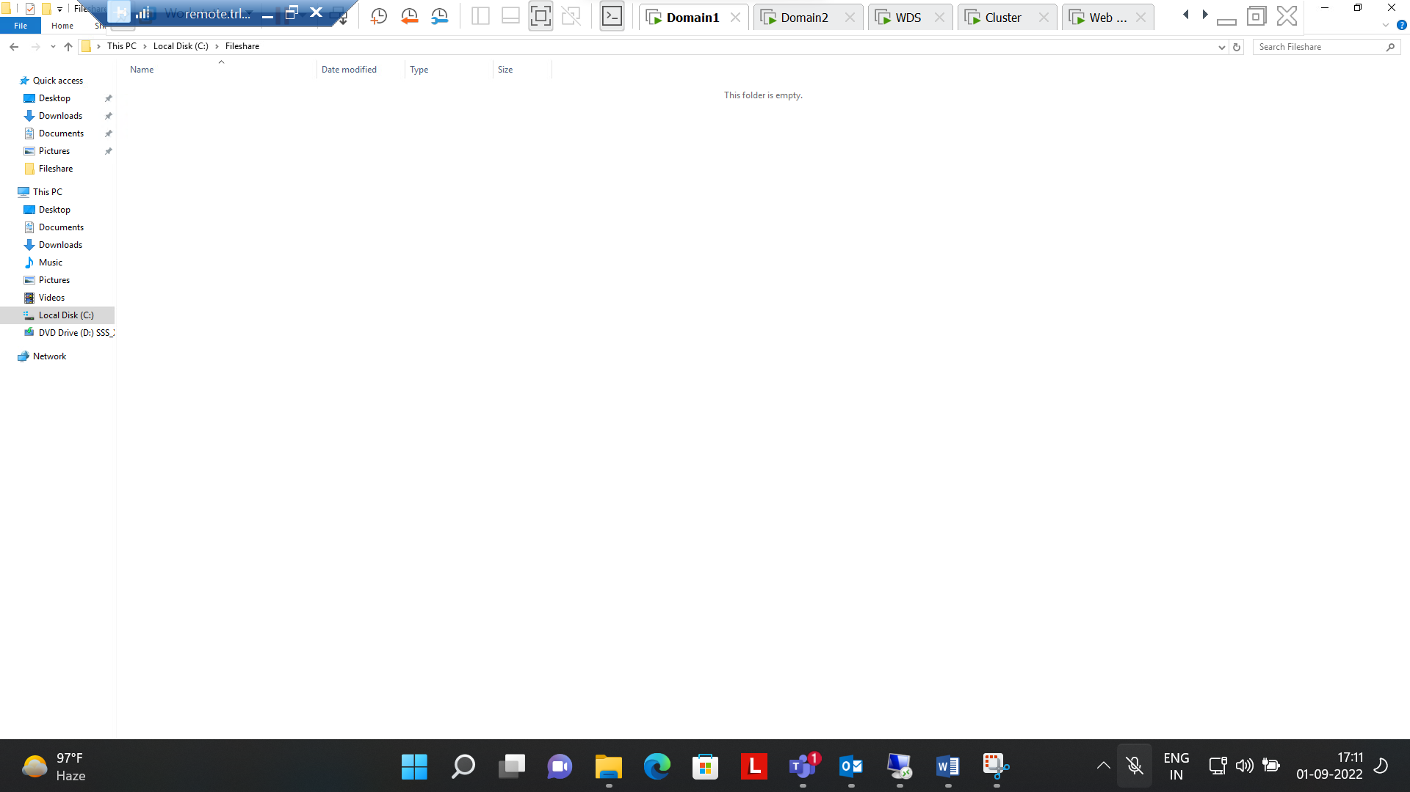

Step4 :- Selected the Backup folder and time from remote folder

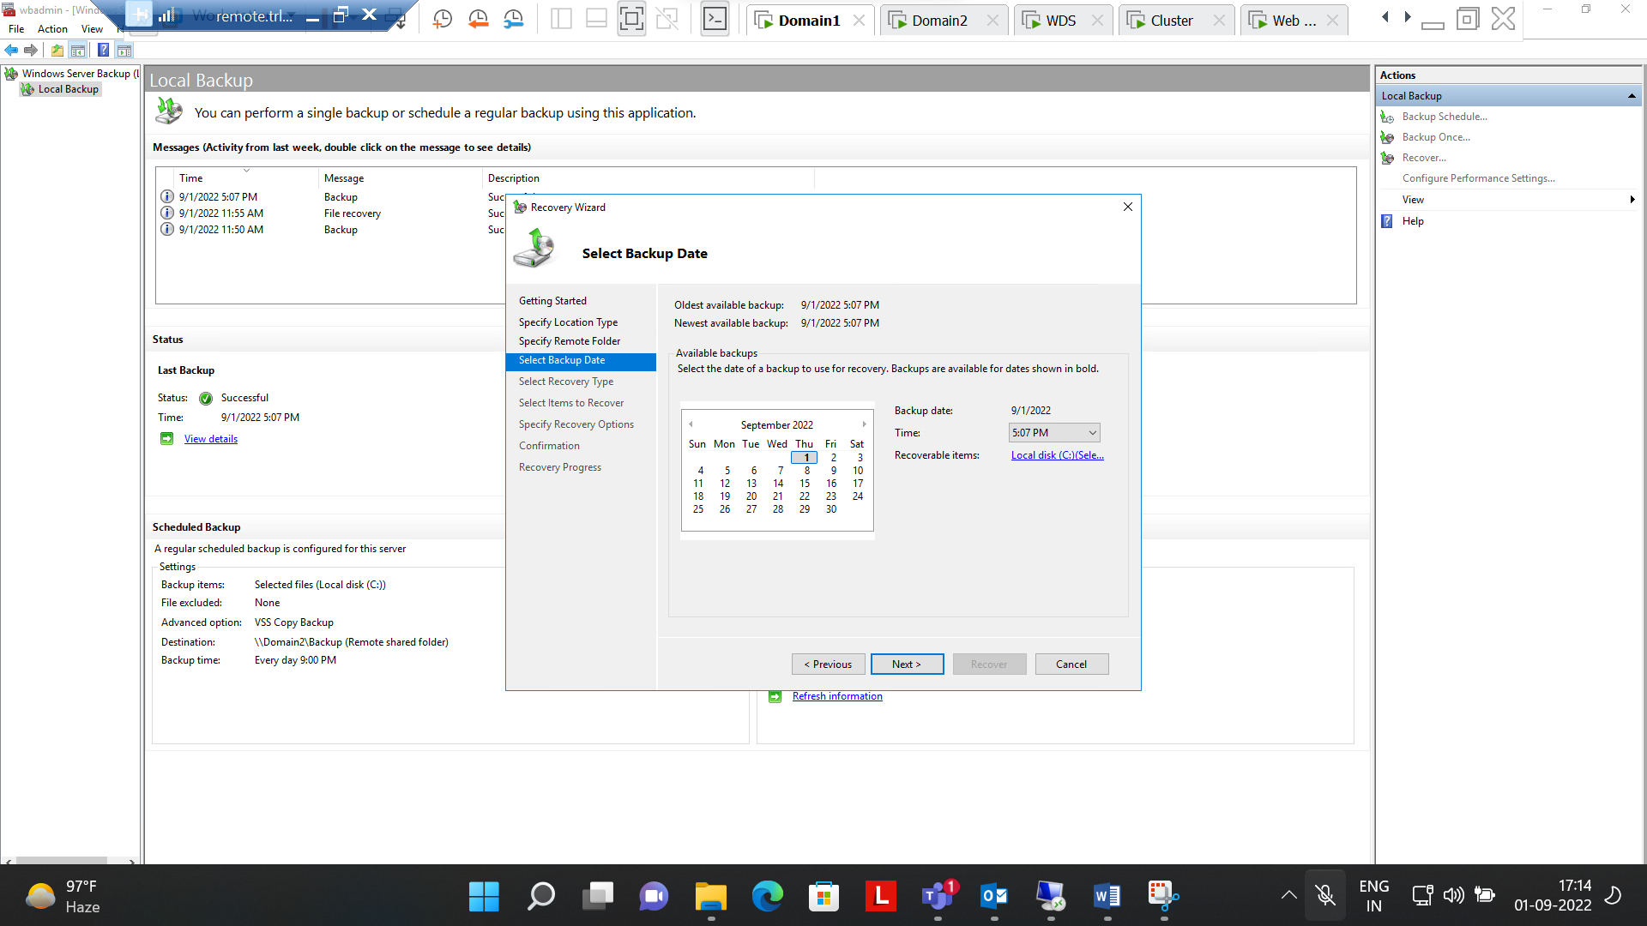

**Step 5:- Selected item(Folder) to be recovered in Domain 1**

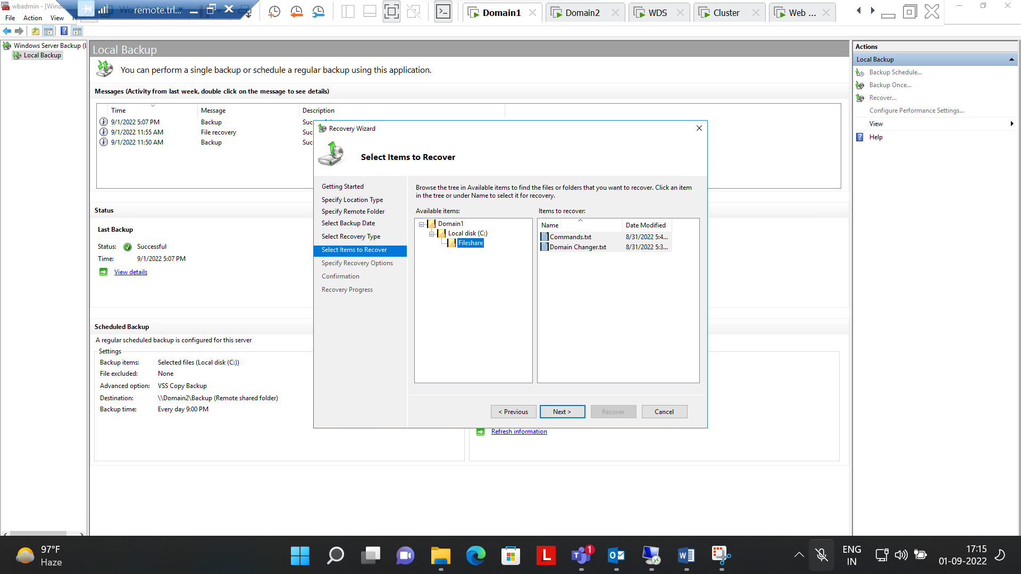

**Step 6 :- Recovered Successfully the files from shared folder(Backup) to original folder(Fileshare)**

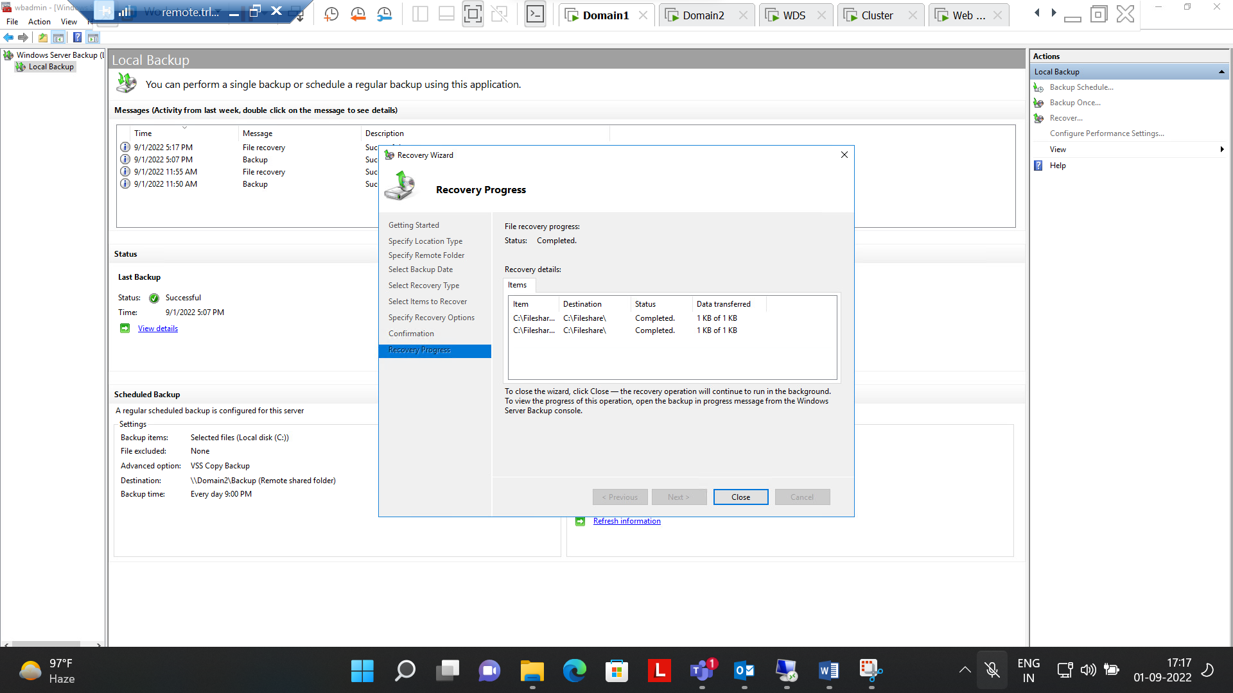

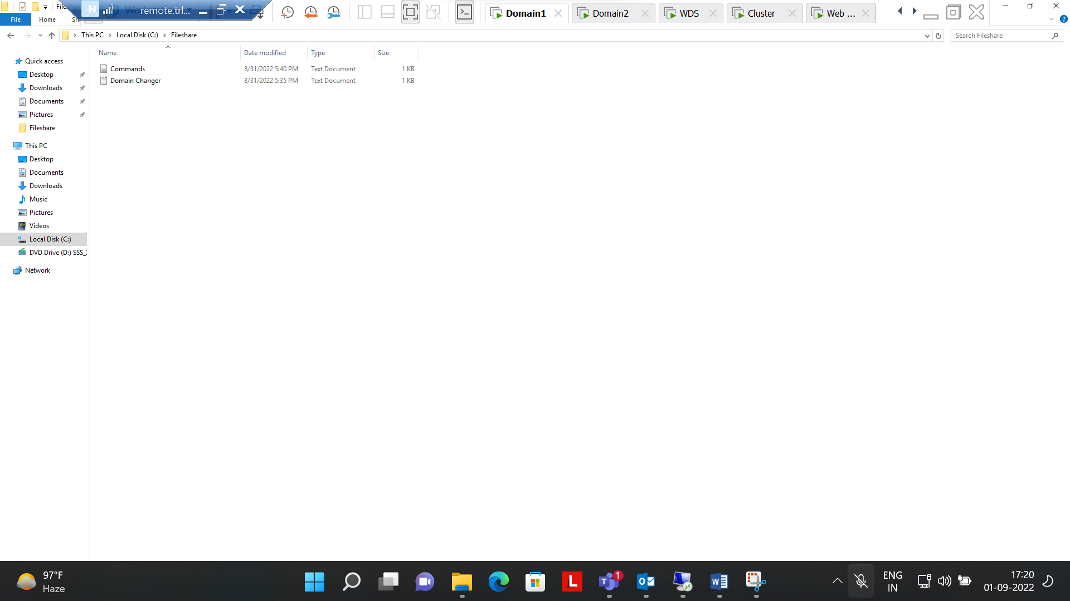

**Question Number 3 Completed**

**Q.4.Implement network deployment of a Windows 7 OS to clients. Ensure you don’t miss to capture the screenshot of IP address display in the client when loading from WDS. Verify if it is working (Verify if it is reaching to 1% progress of OS installation).**

**Ans:-**

**Step 1:- Selected the path for remote installation folder location**

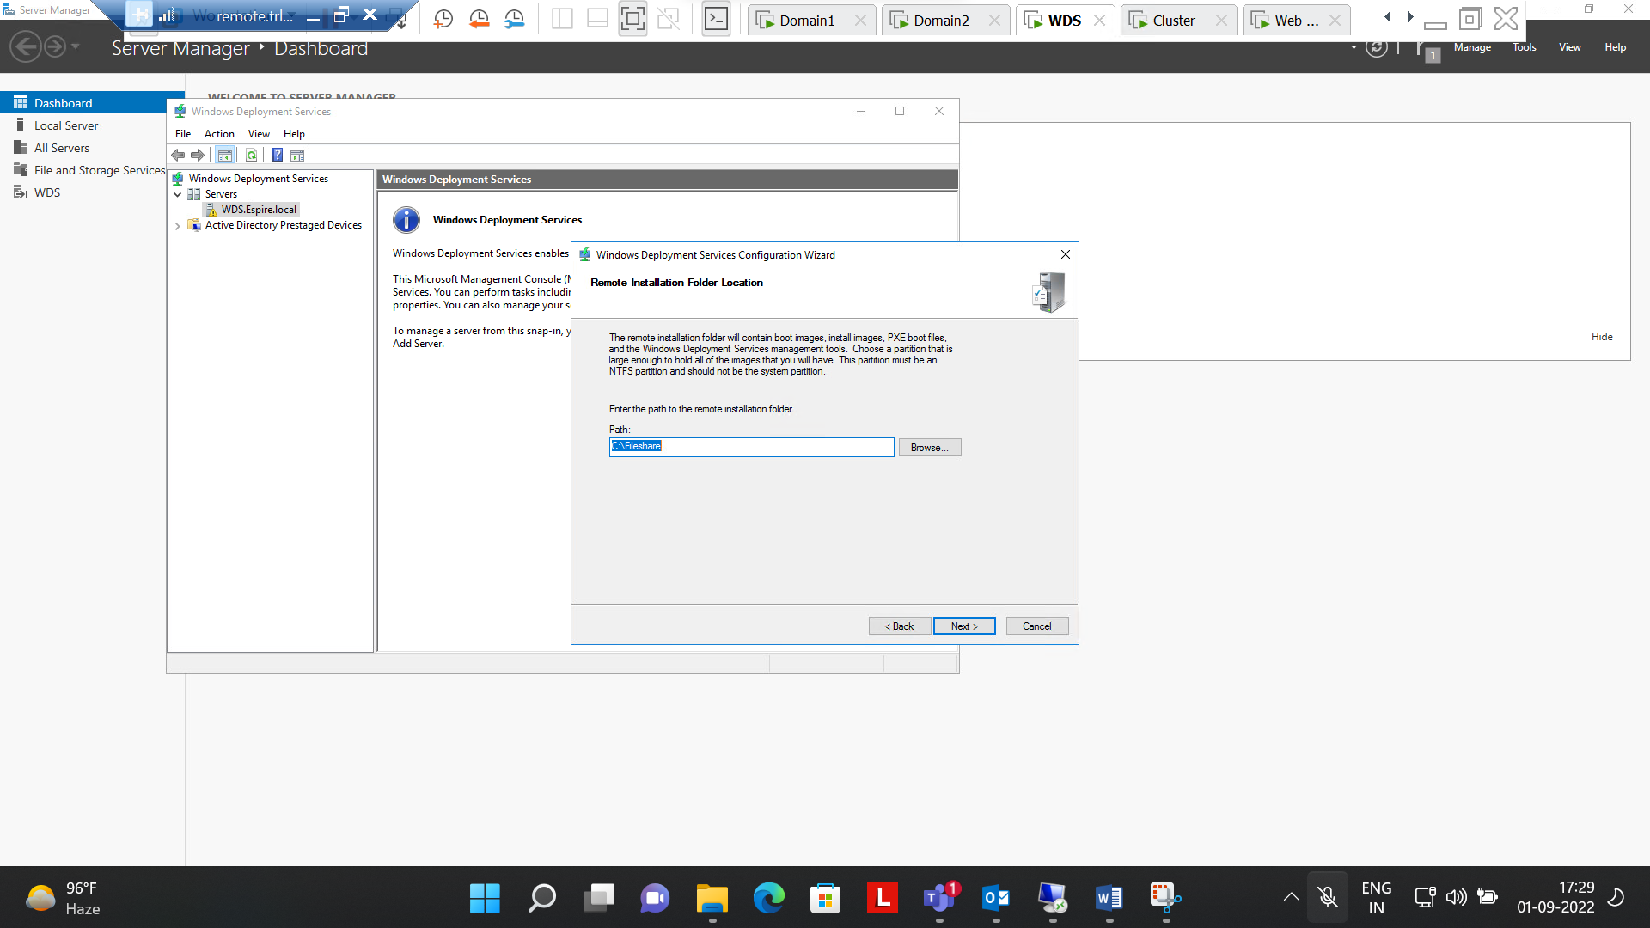

**Step 2:- Boot Images & Install images added successfully**

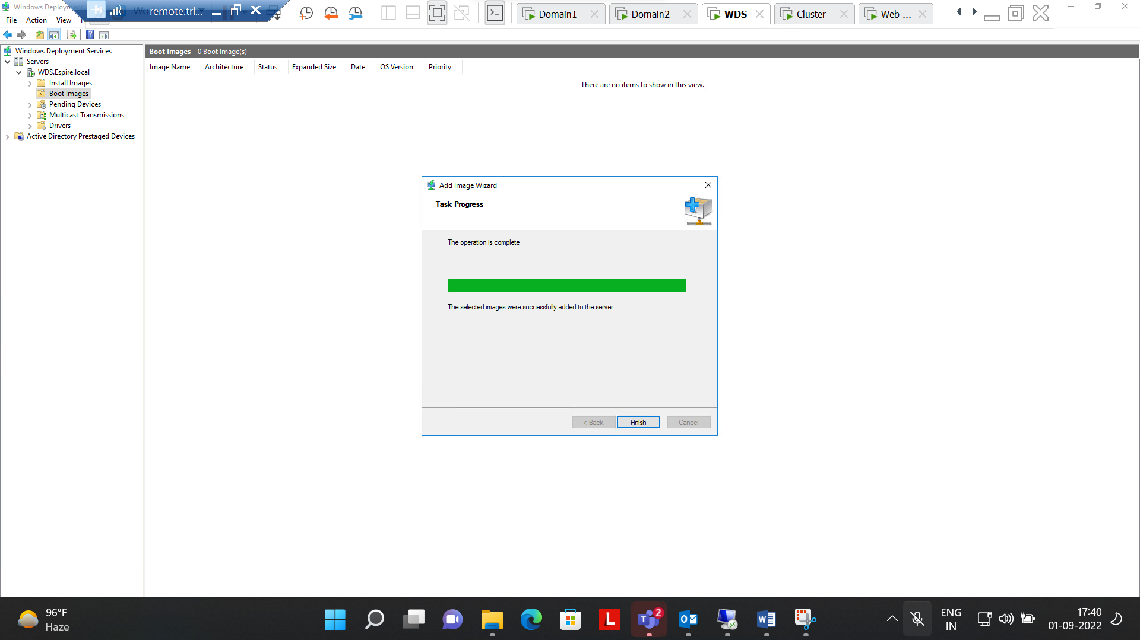

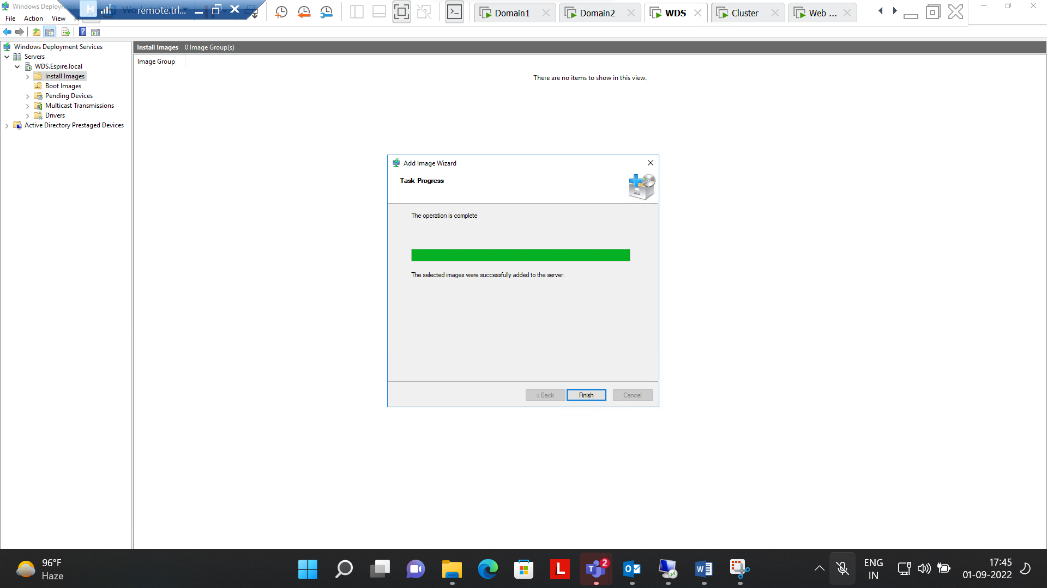

**Step 3:- Fetching CD drive from WDS (192.168.100.3)**

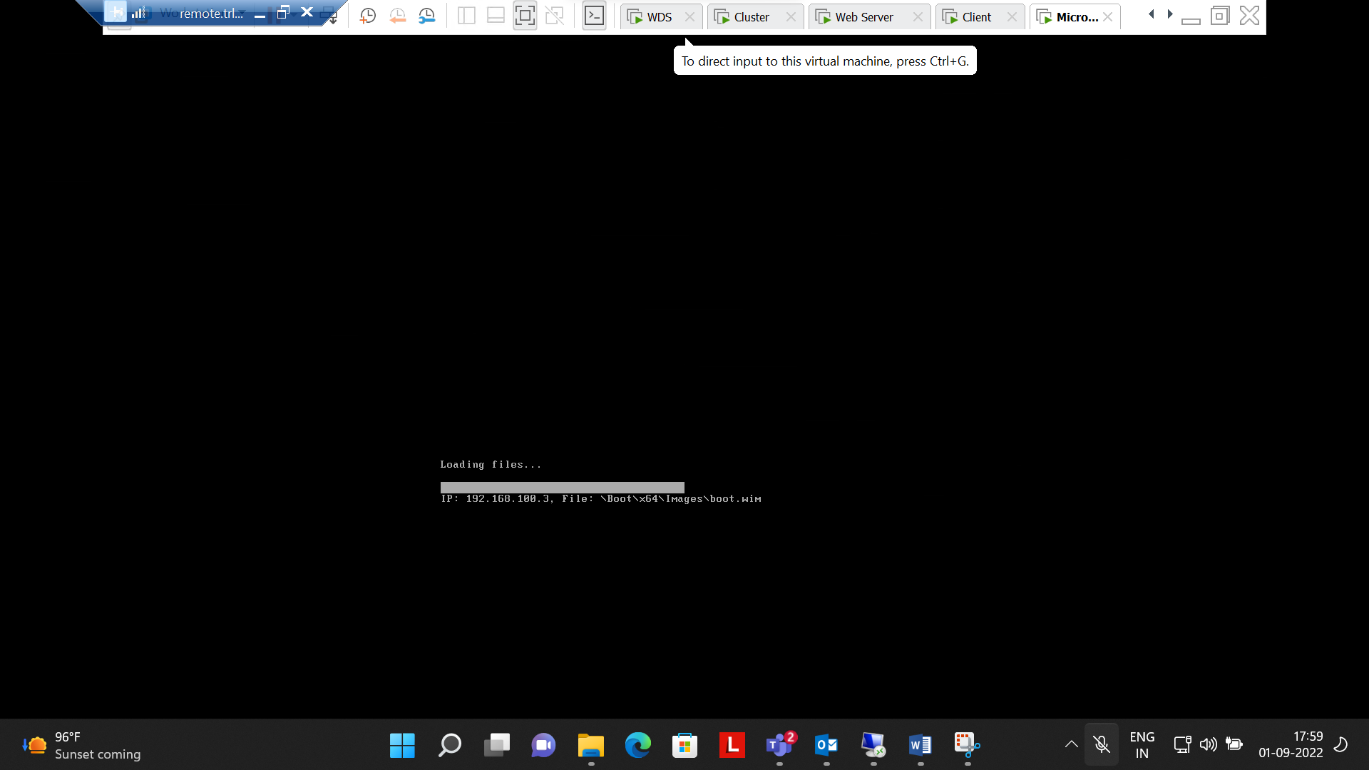

**Step 4:- Successfully Operated installation process**

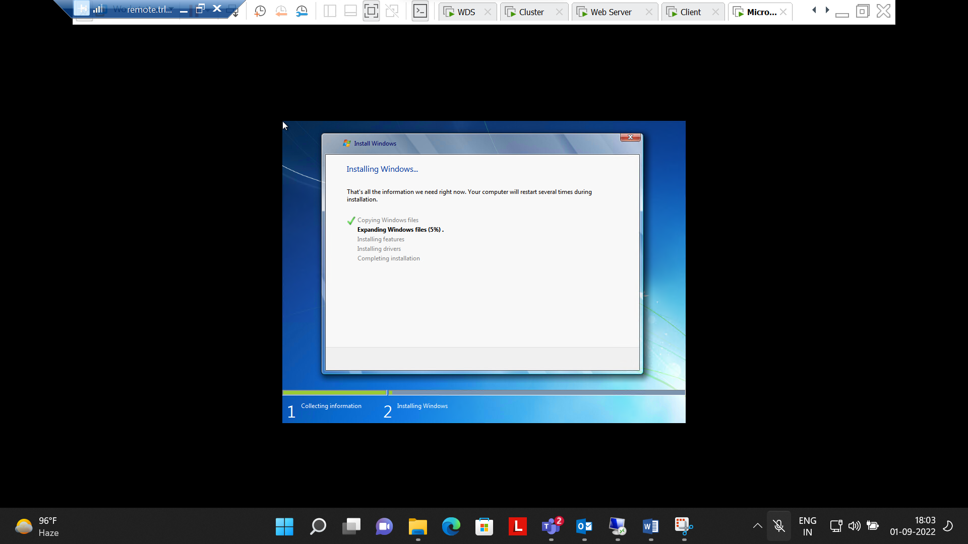

**Question number 4 Successfully Completed**

**Q5.Transfer all FSMO roles to the ADC using GUI and transfer back to DC using Powershell. Verify if it worked using command line.**

Ans :-

Step1 :- Master Role for RID, PDC, Infrastructure changed to Domain 2 from Domain 1

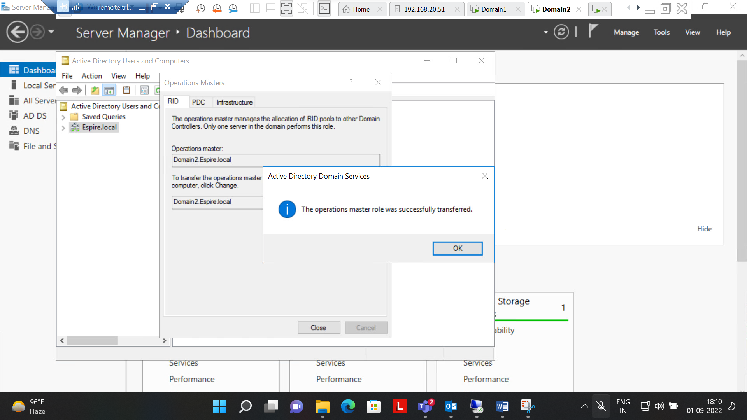

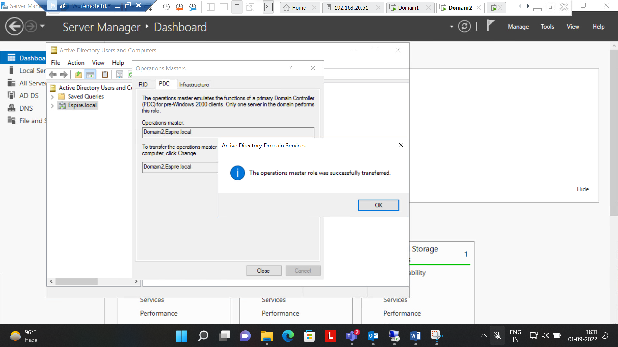

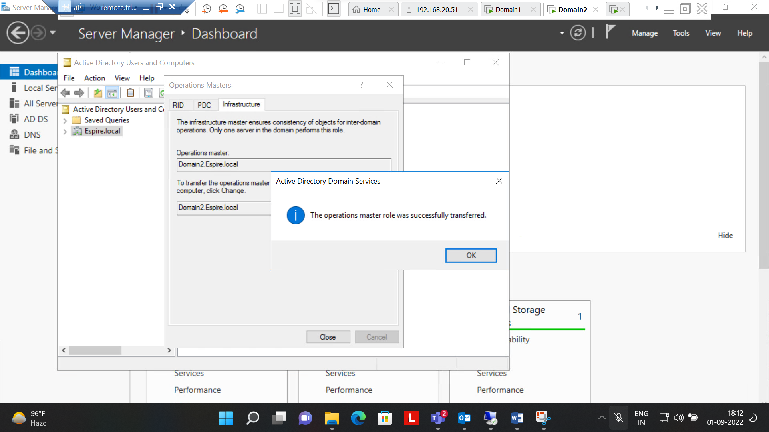

Step 2 :- Changed all controls to Domain2 from Domain1

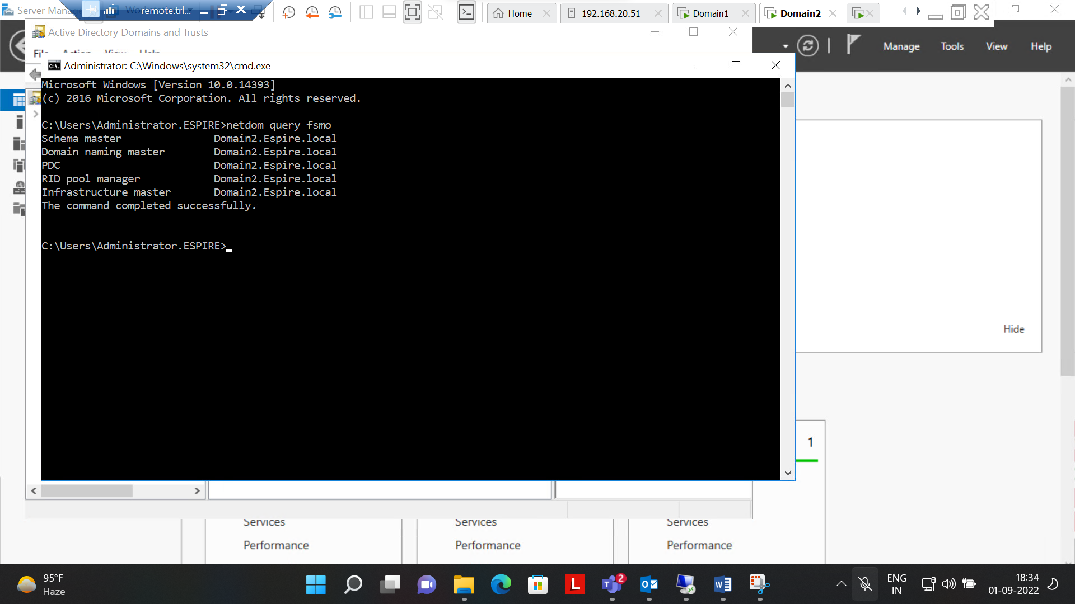

Step3:- Implemented Changing controls to domain 1 from domain 2 using powershell.

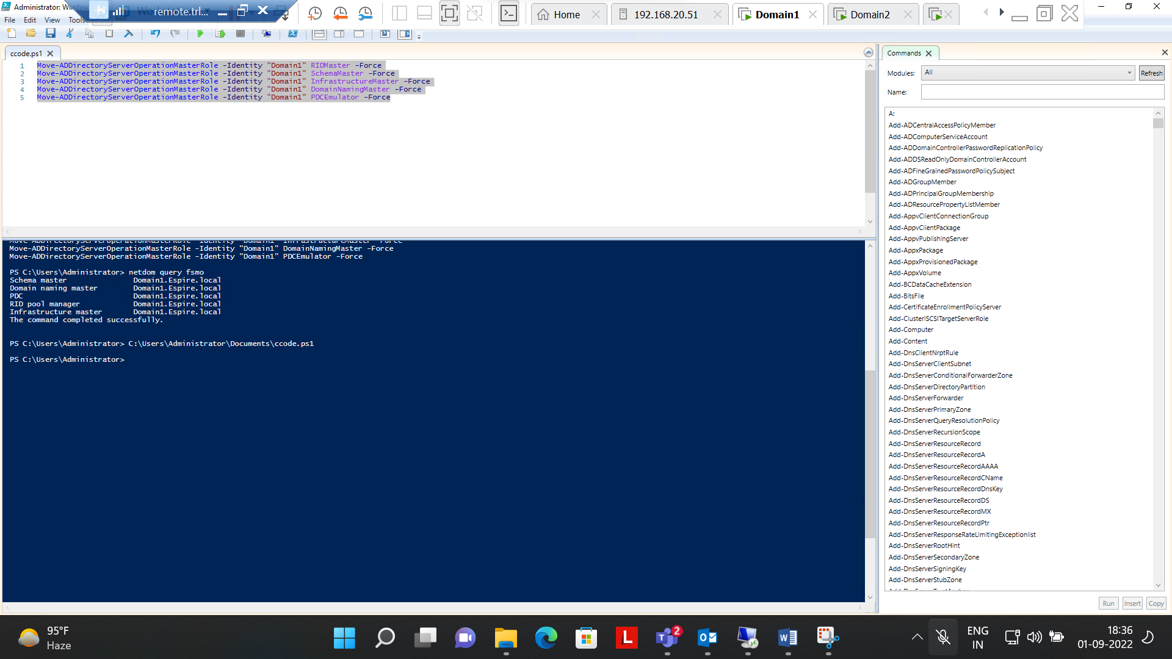

Step 4:- Checked all controls changed to domain 1 from domain 2 using CMD

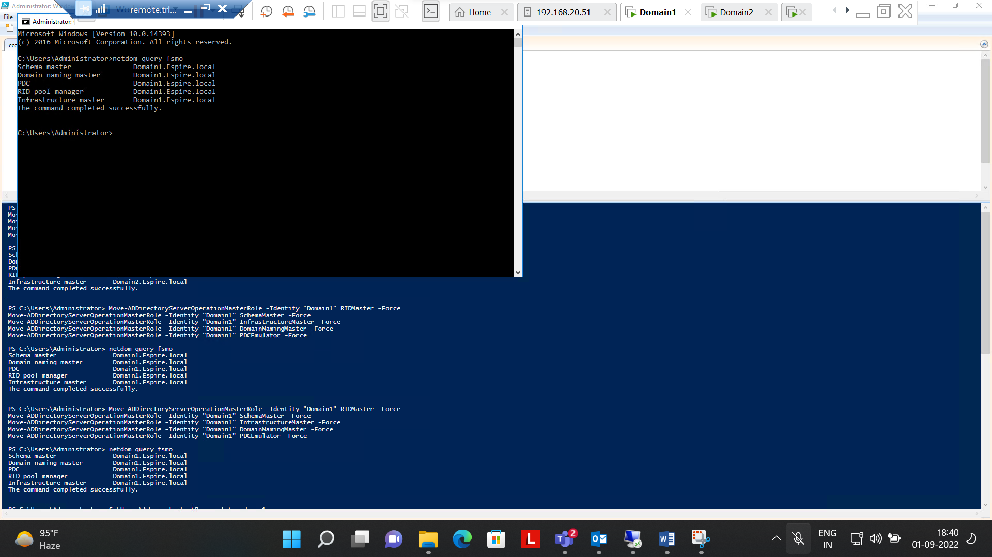

**Questions number 5 Completed Successfully.**

**6.Perform installing and Configuring IIS, Create a website with a webpage, Test if it is accessible from the client, protect the Website With SSL**

**Ans:-**

**Step 1:- Installed role of Web server(IIS) on both machines i.e. Cluster and web Server**

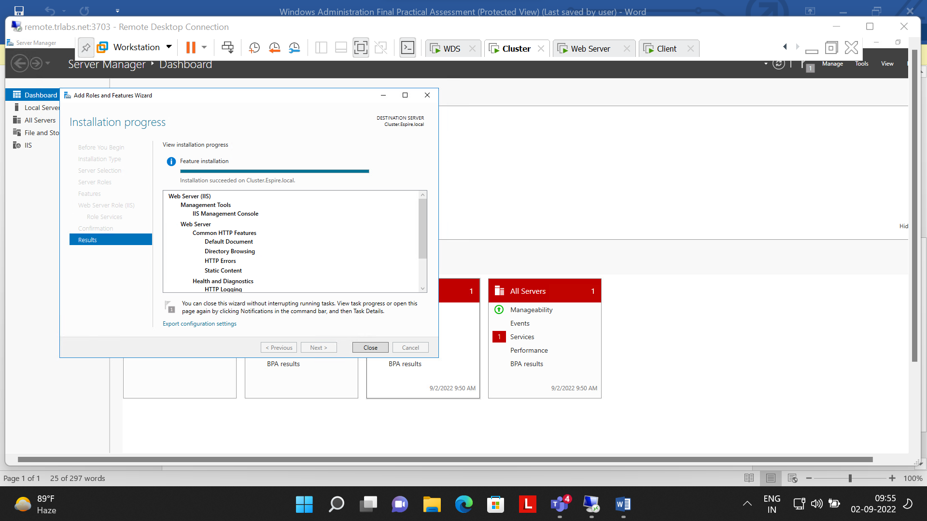

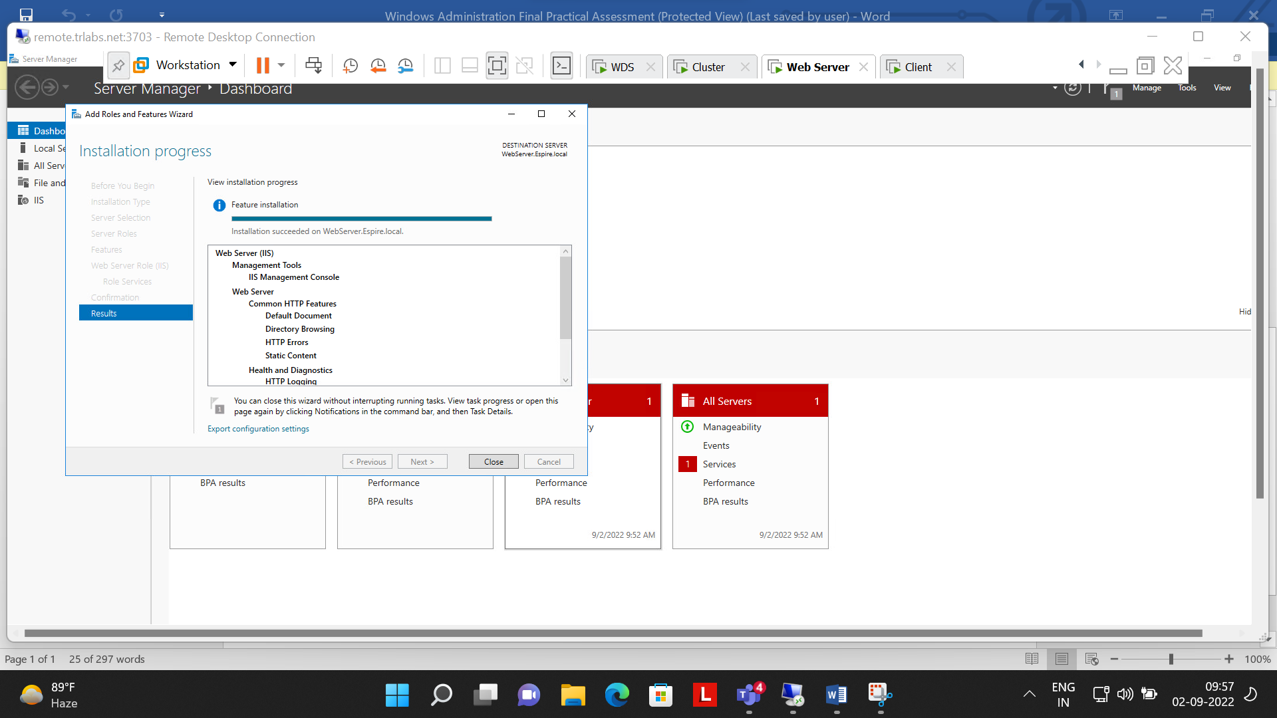

Step 2 :- Installed role of Active Directory Certificate Services in Domain 1

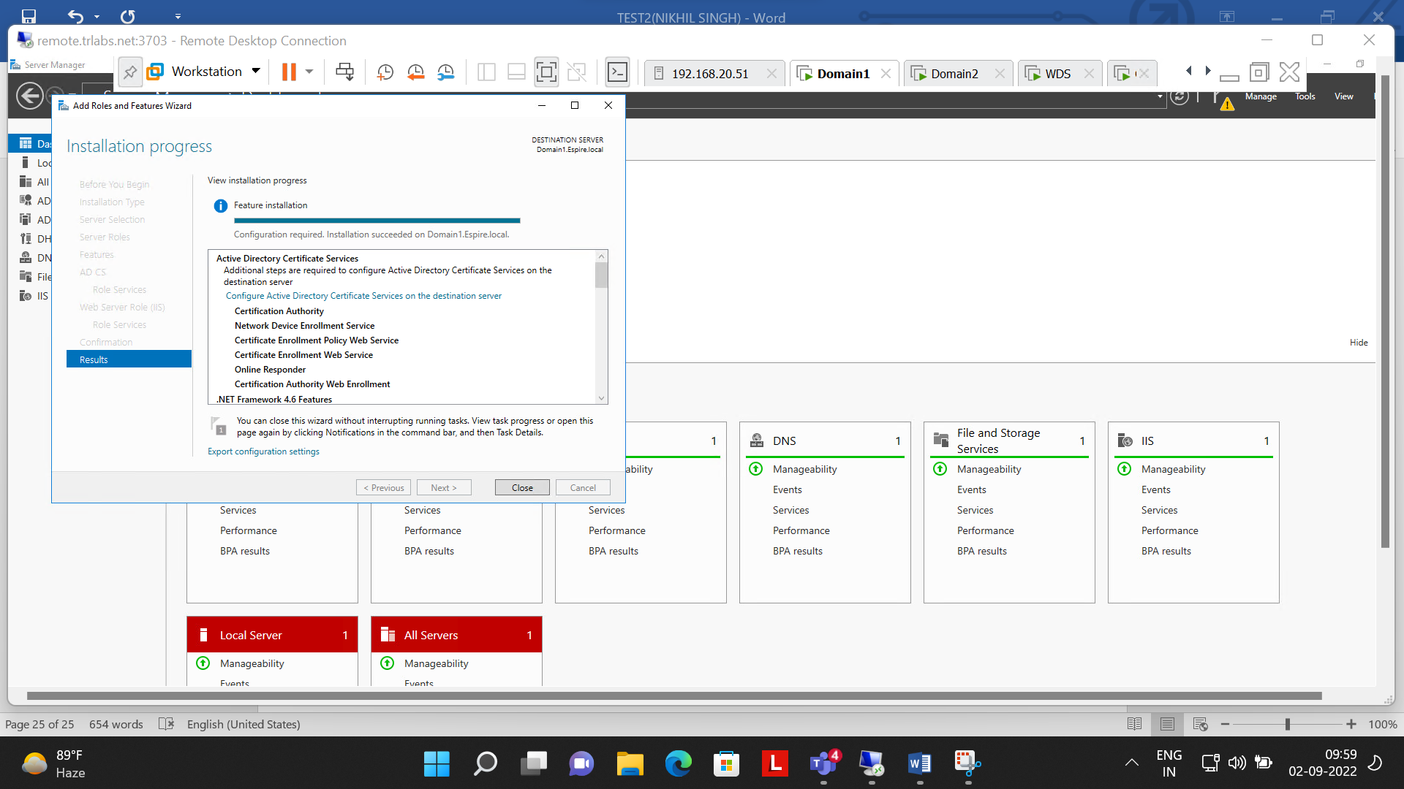

Step 3:- Selected Role Services to configure

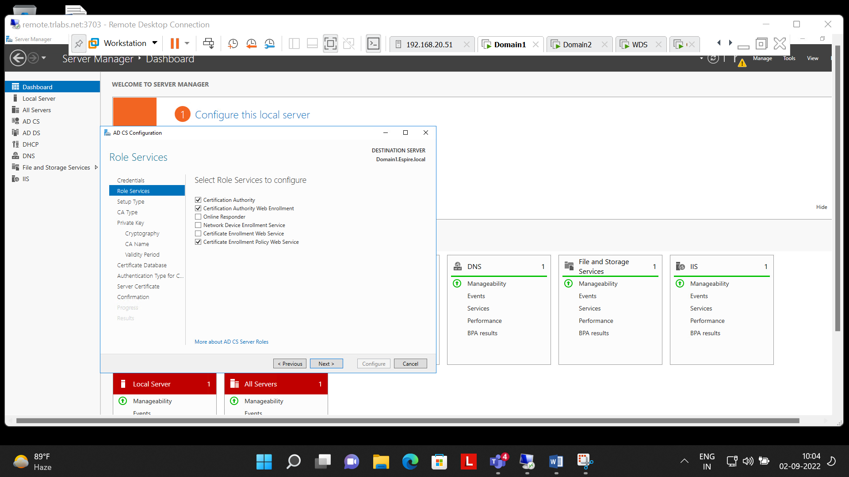

Step 4:- Specified the cryptographic options(SHA512)

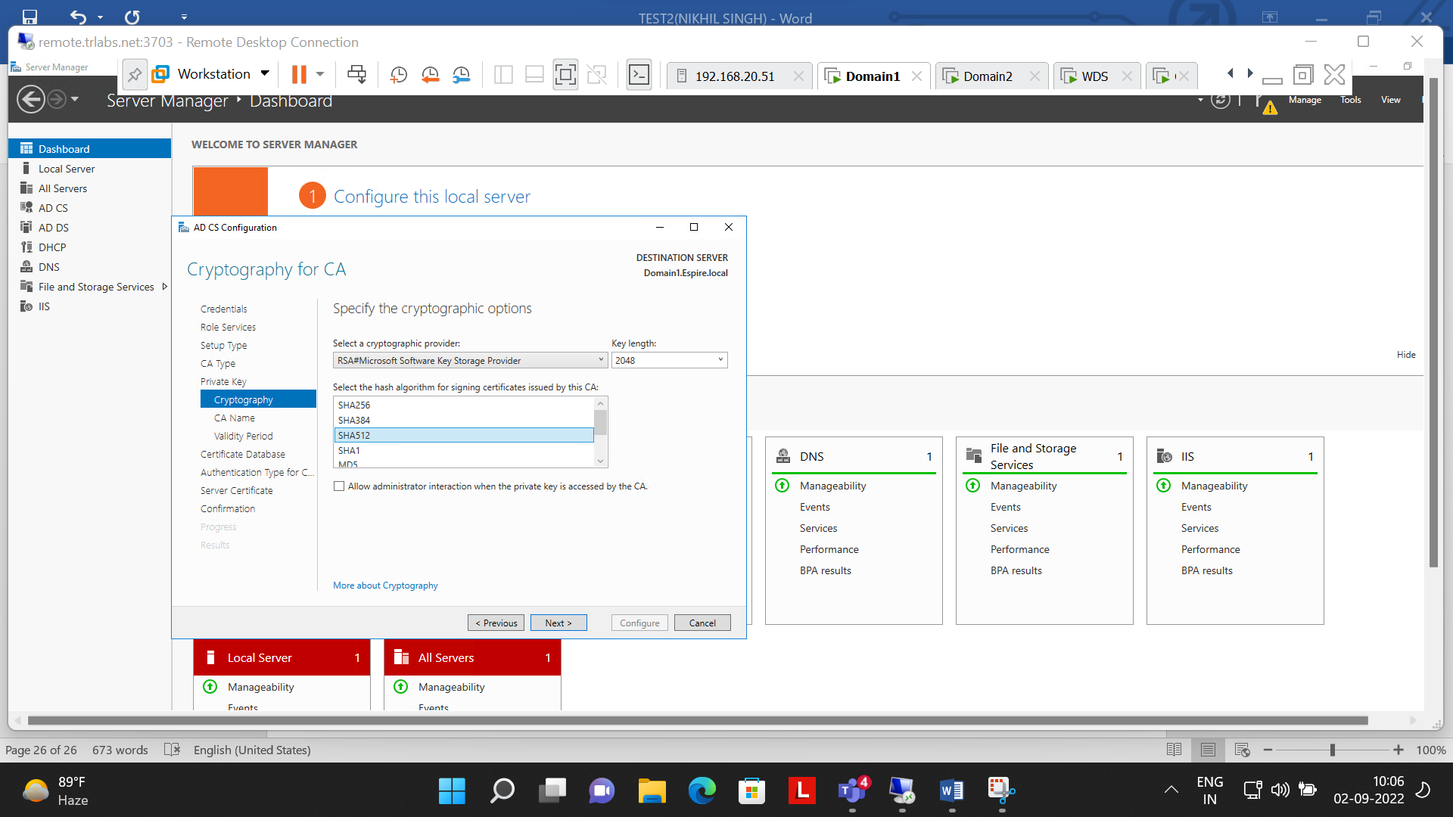

Step 5:- Configuration successful of AD CS

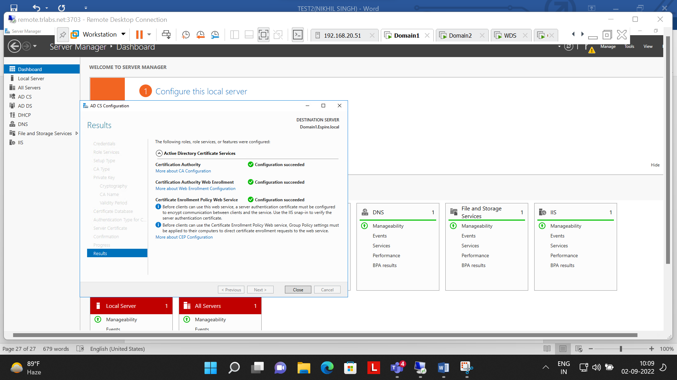

Step 6:- Online Certificate Authority

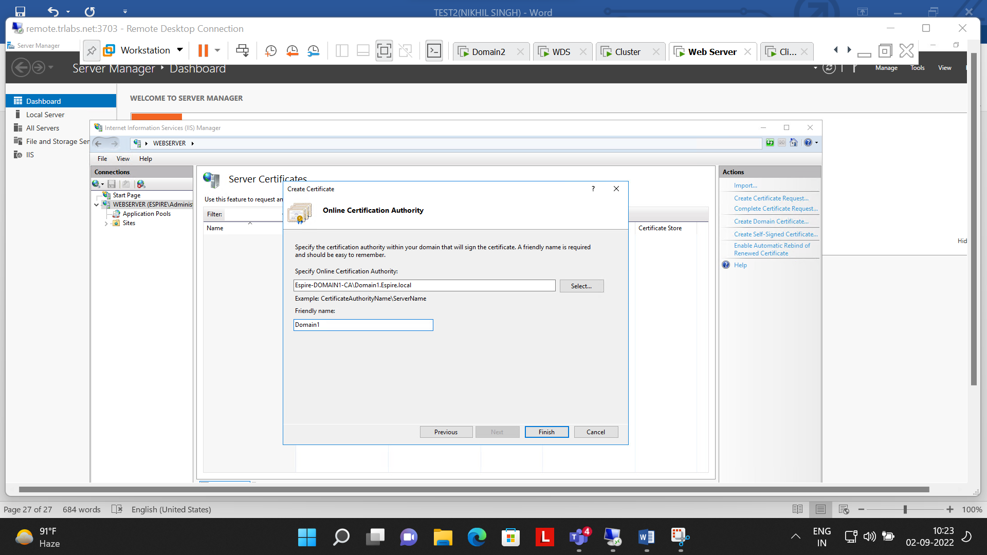

Step 7:- Certificate issued by Domain 1 to webserver

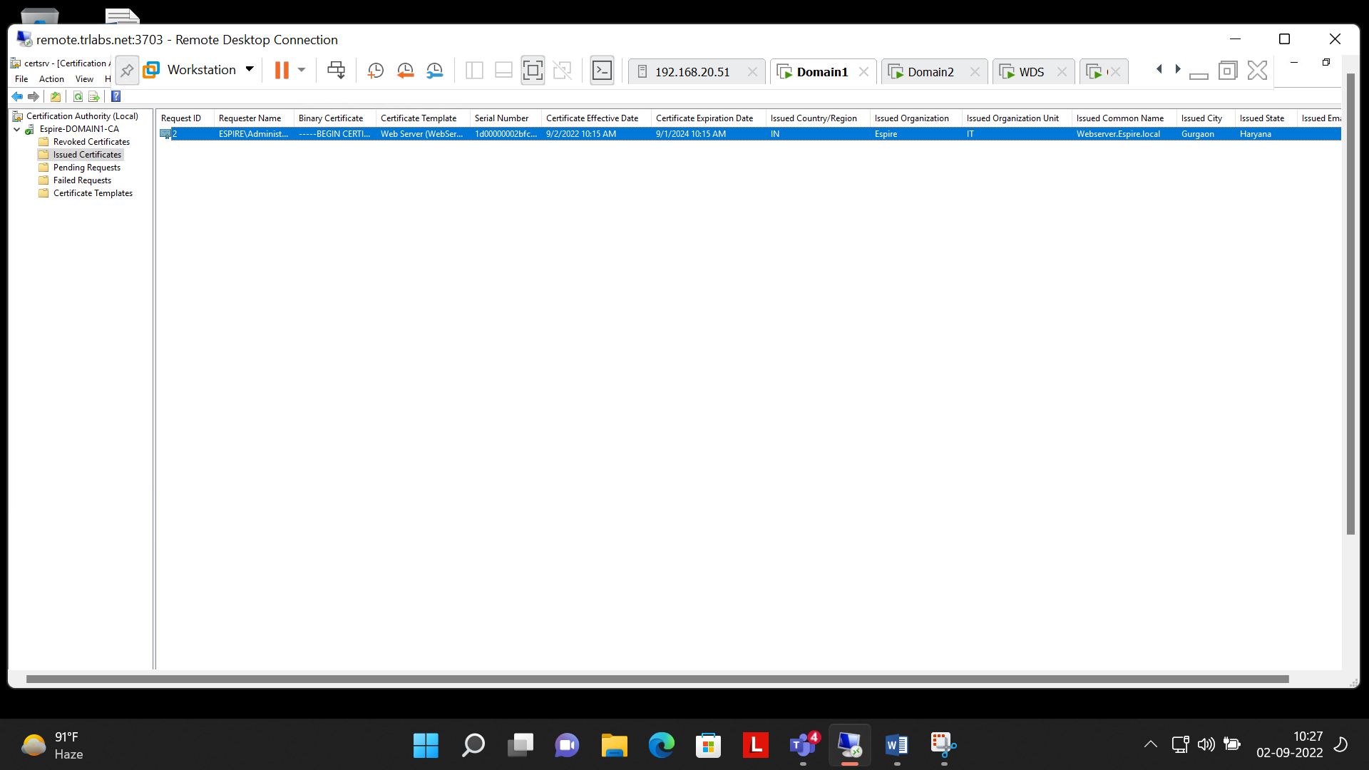

Step 8:- Binding Done in Webserver for(HTTPS)

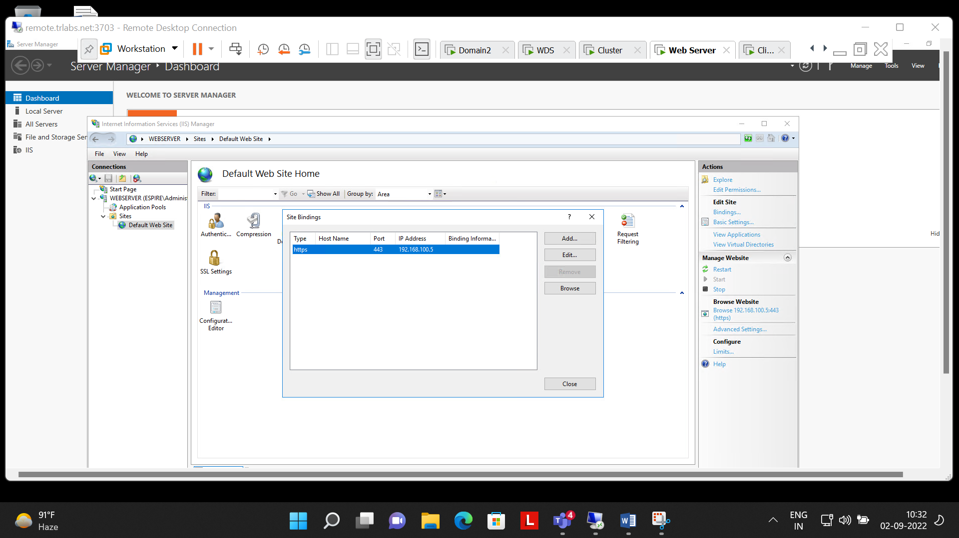

Step 9:- successfully Checked that webserver Site can be accessed from client machine with another user with HTTPS security, i.e. (SSL)

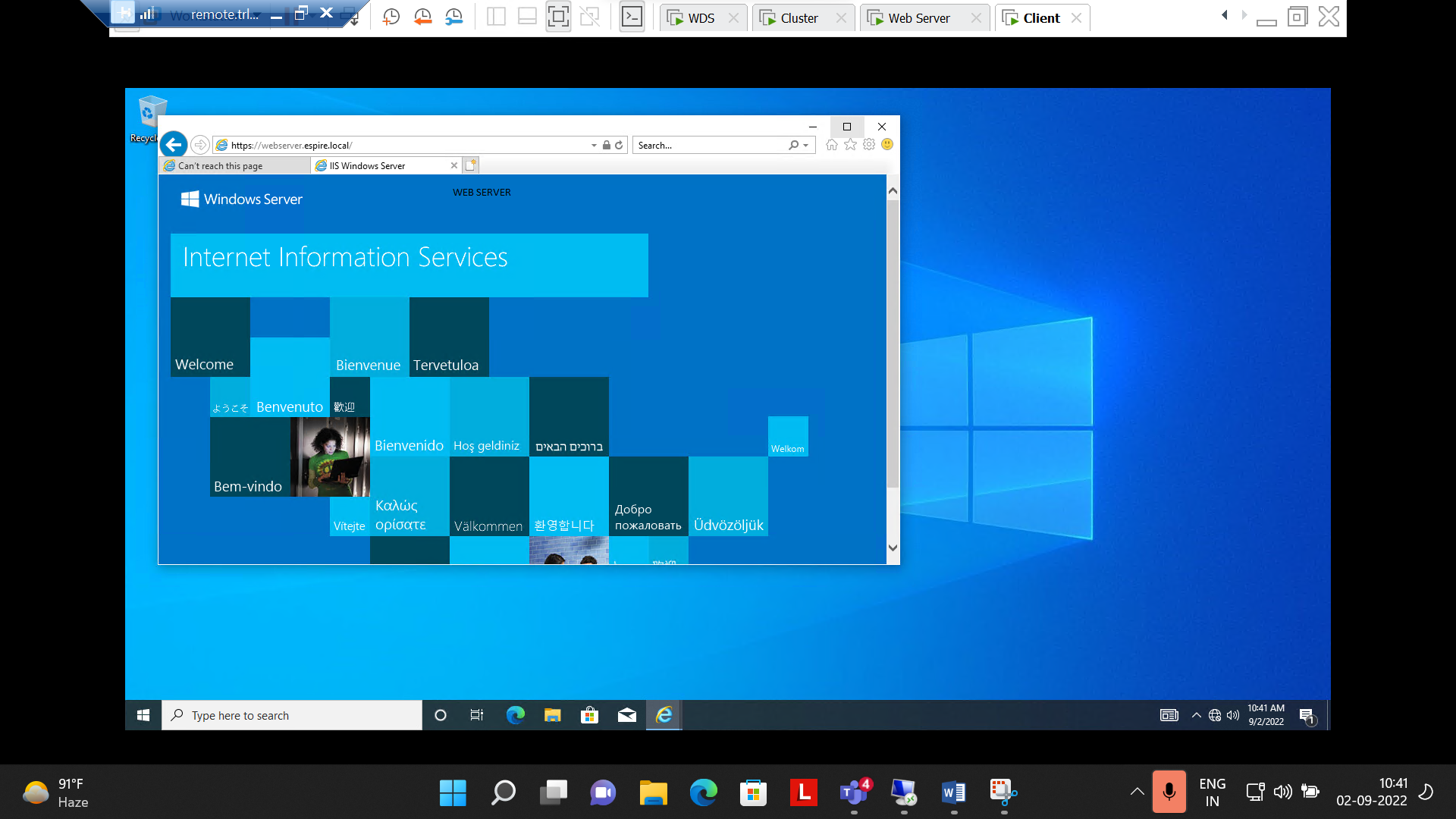

**Questions Number 6 Completed Successfully**

**Q.7.Perform installing and Configuring Network load balancing feature , add two web servers and show the result of load balancing when both the web server is on and if one web server is down.**

**Ans:-**

Step 1:- Installed Feature of Network Load Balancing in Cluster and Web Server

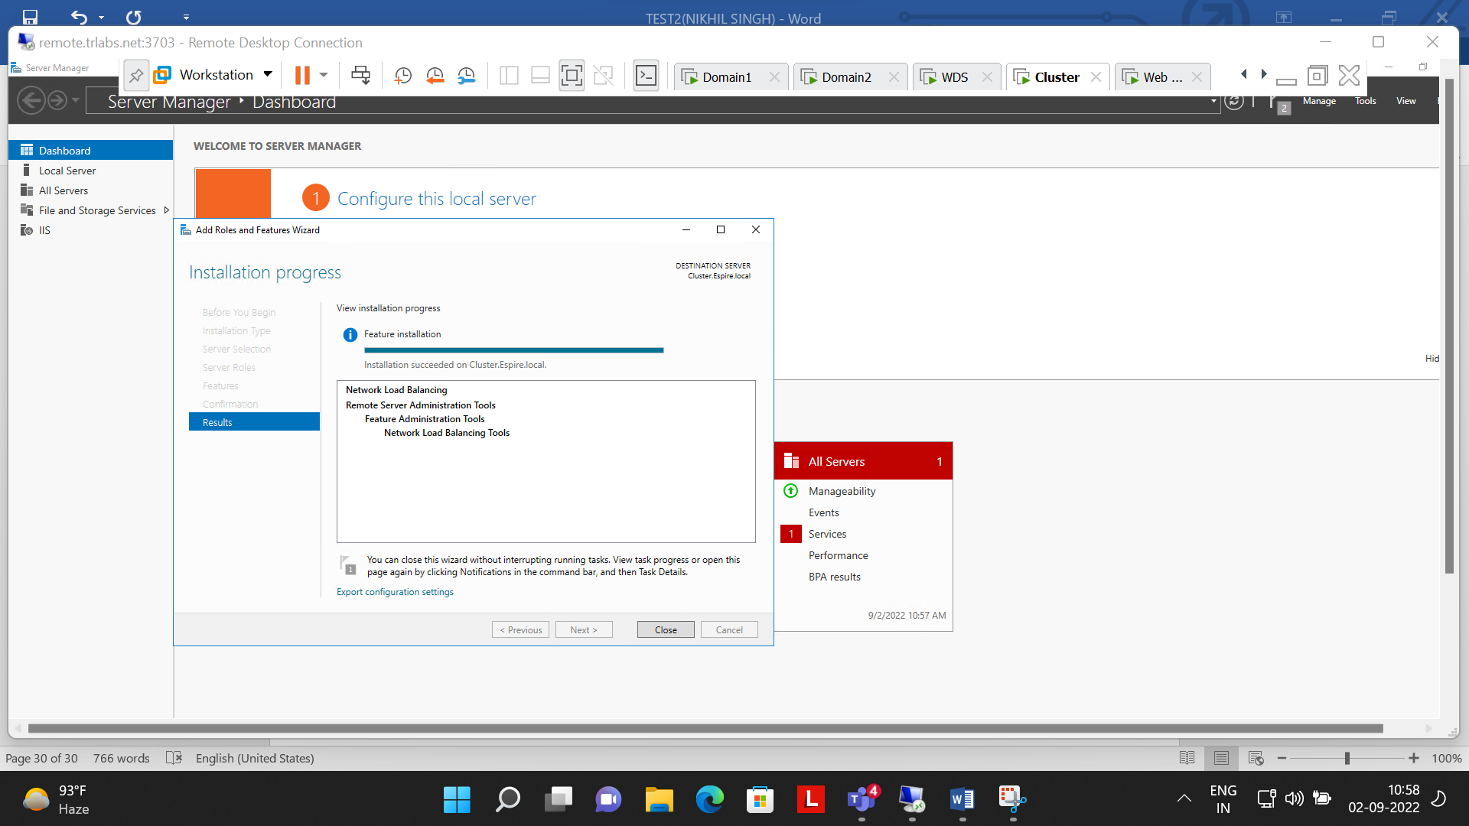

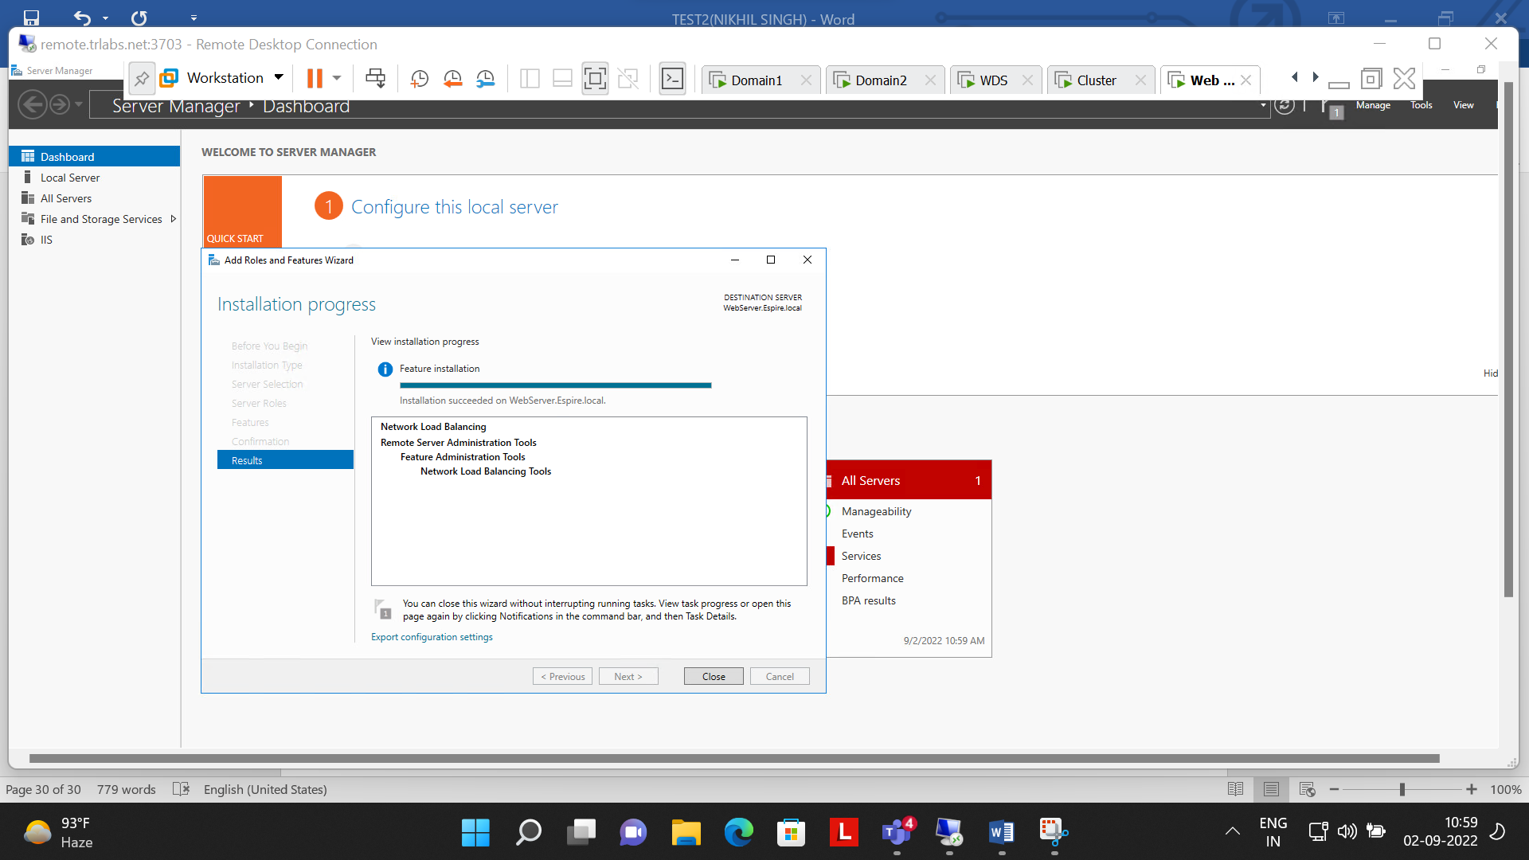

Step 2:- Created Host(A) i.e. 192.168.100.4 , 192.168.100.5 & nlb(192.168.100.55)

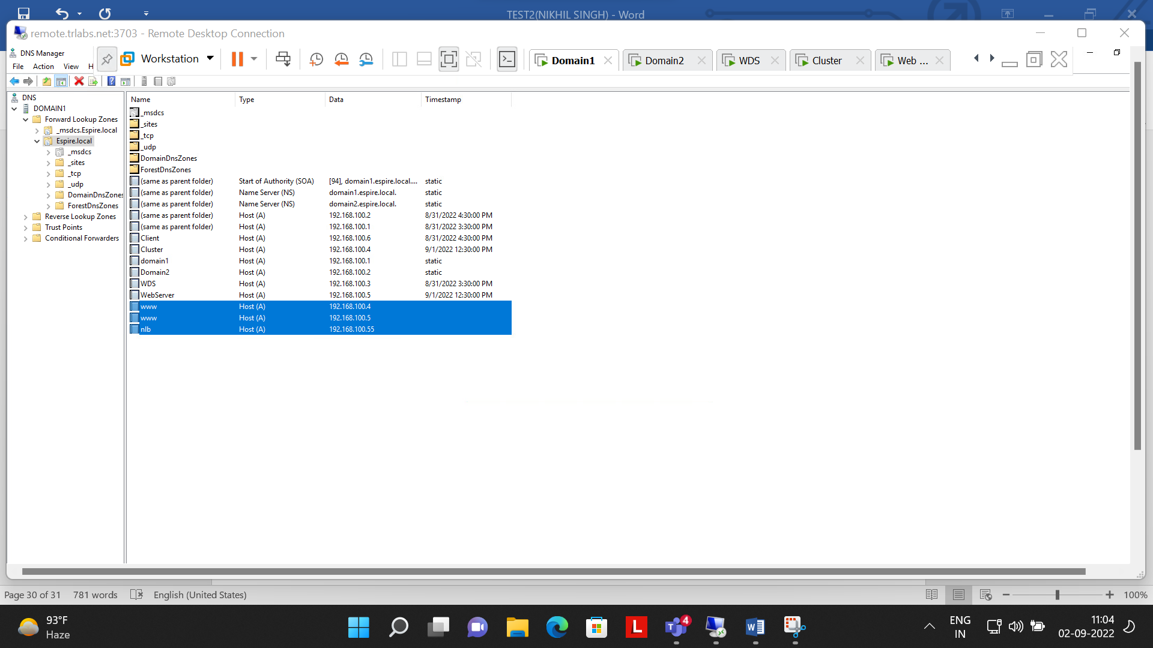

Step3:- Creating new cluster for webserver

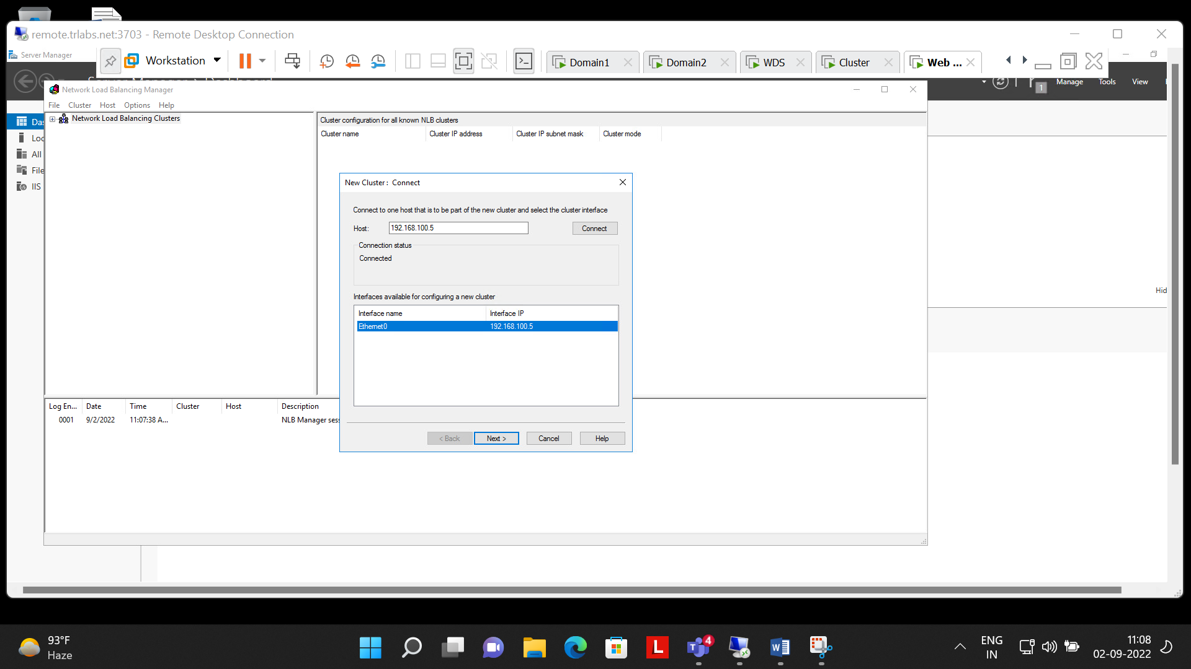

Step 4:-Added the cluster IP address (nlb :- 192.168.100.55)

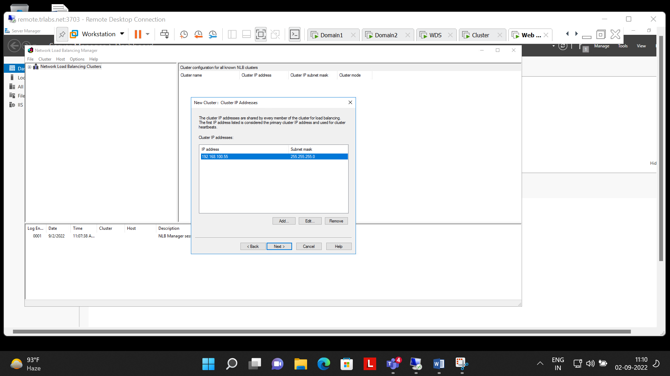

Step 5:- cluster parameter

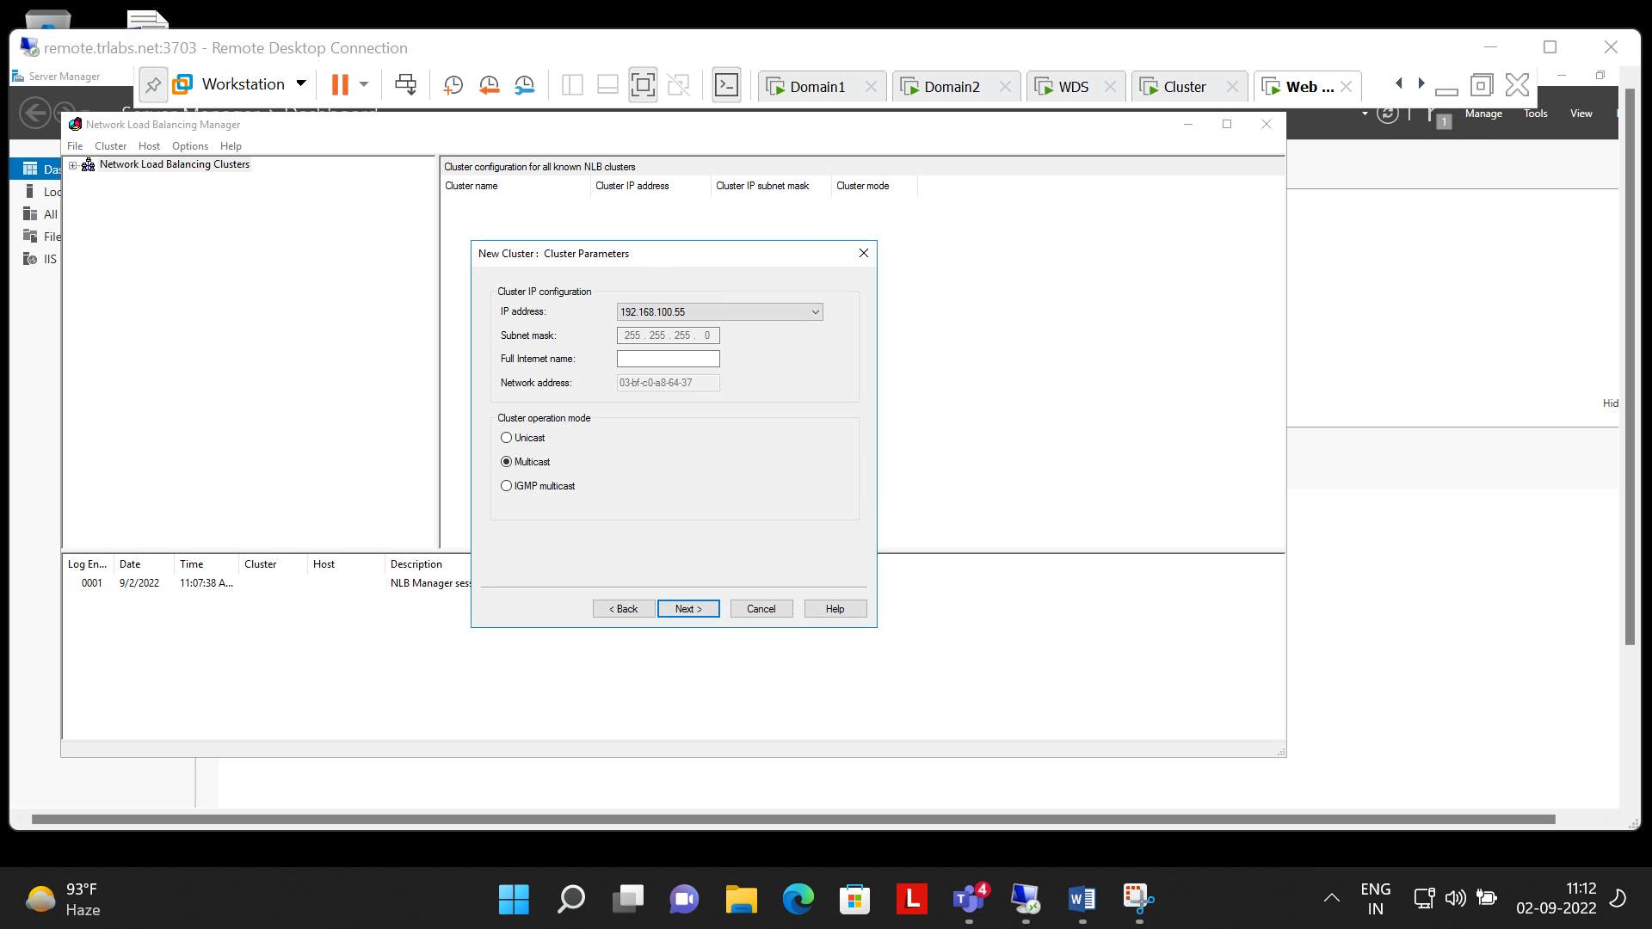

Step 6:- Both The Machines (Cluster & Webserver) are connected with 192.168.100.55(nlb)

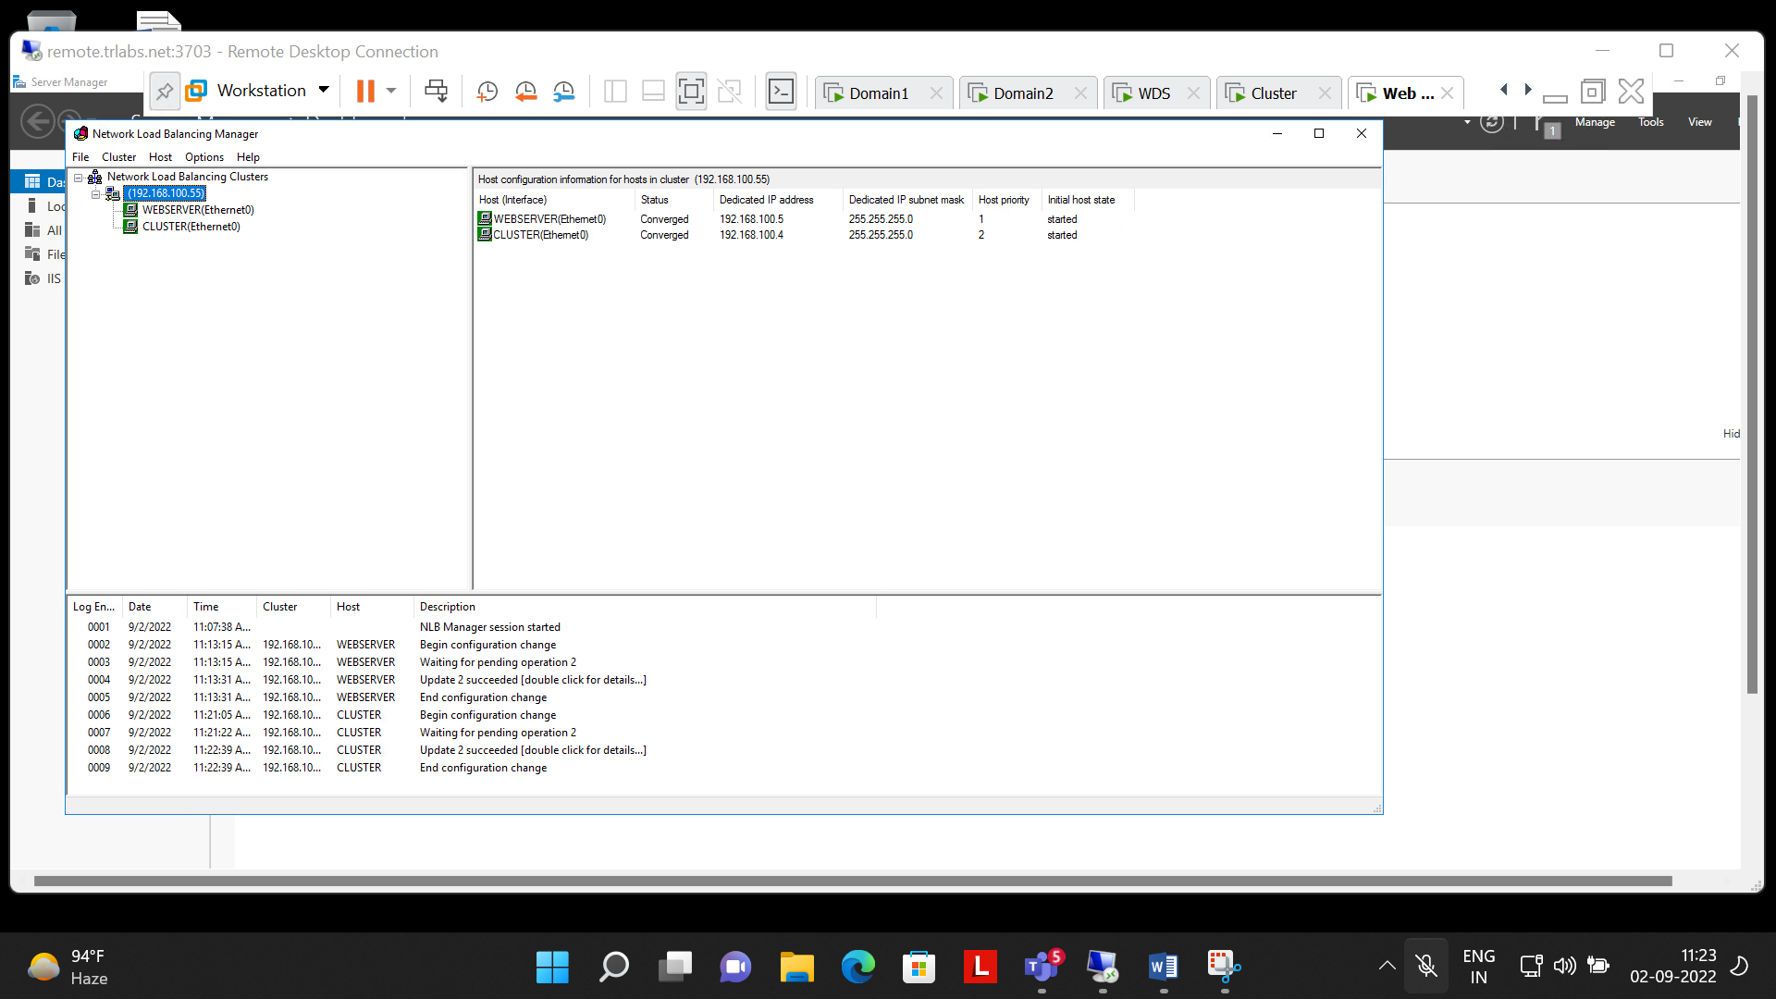

Step 7:- Cluster(192.168.100.4) can be accessed through client 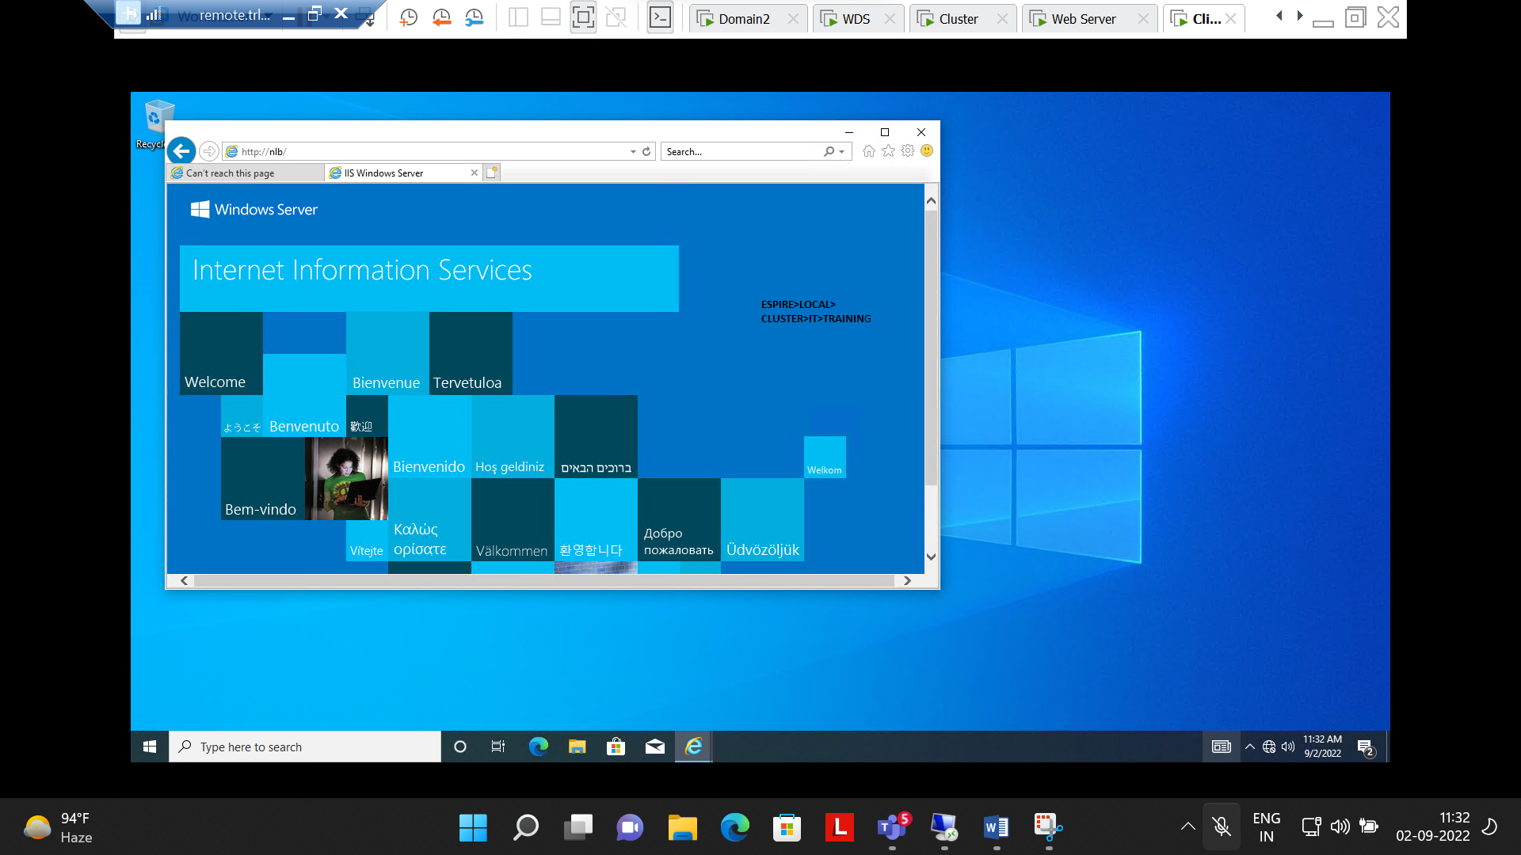

Step 8:- Webserver(192.168.100.5) Can be accessed through client machine after suspending cluster(192.168.100.4)

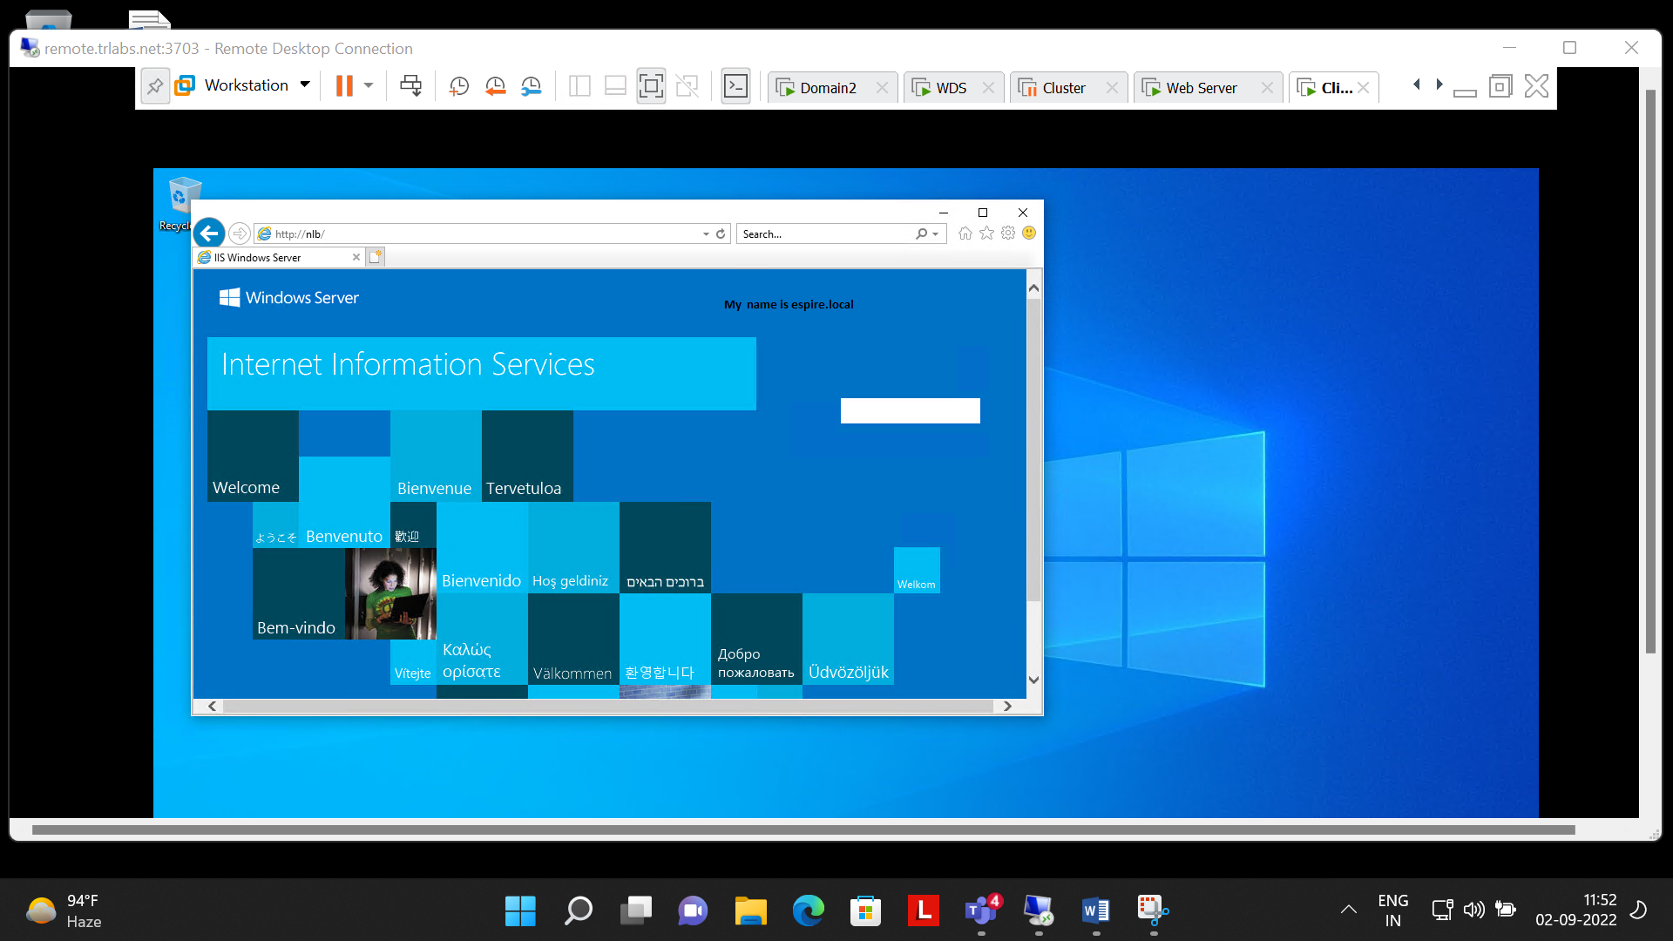

**Questions number 7 load balancing done Successfully**

**Q8.Implement ADC Replication. Verify if it is working**

**Ans:-**

Step1:- Created new site(Bihar)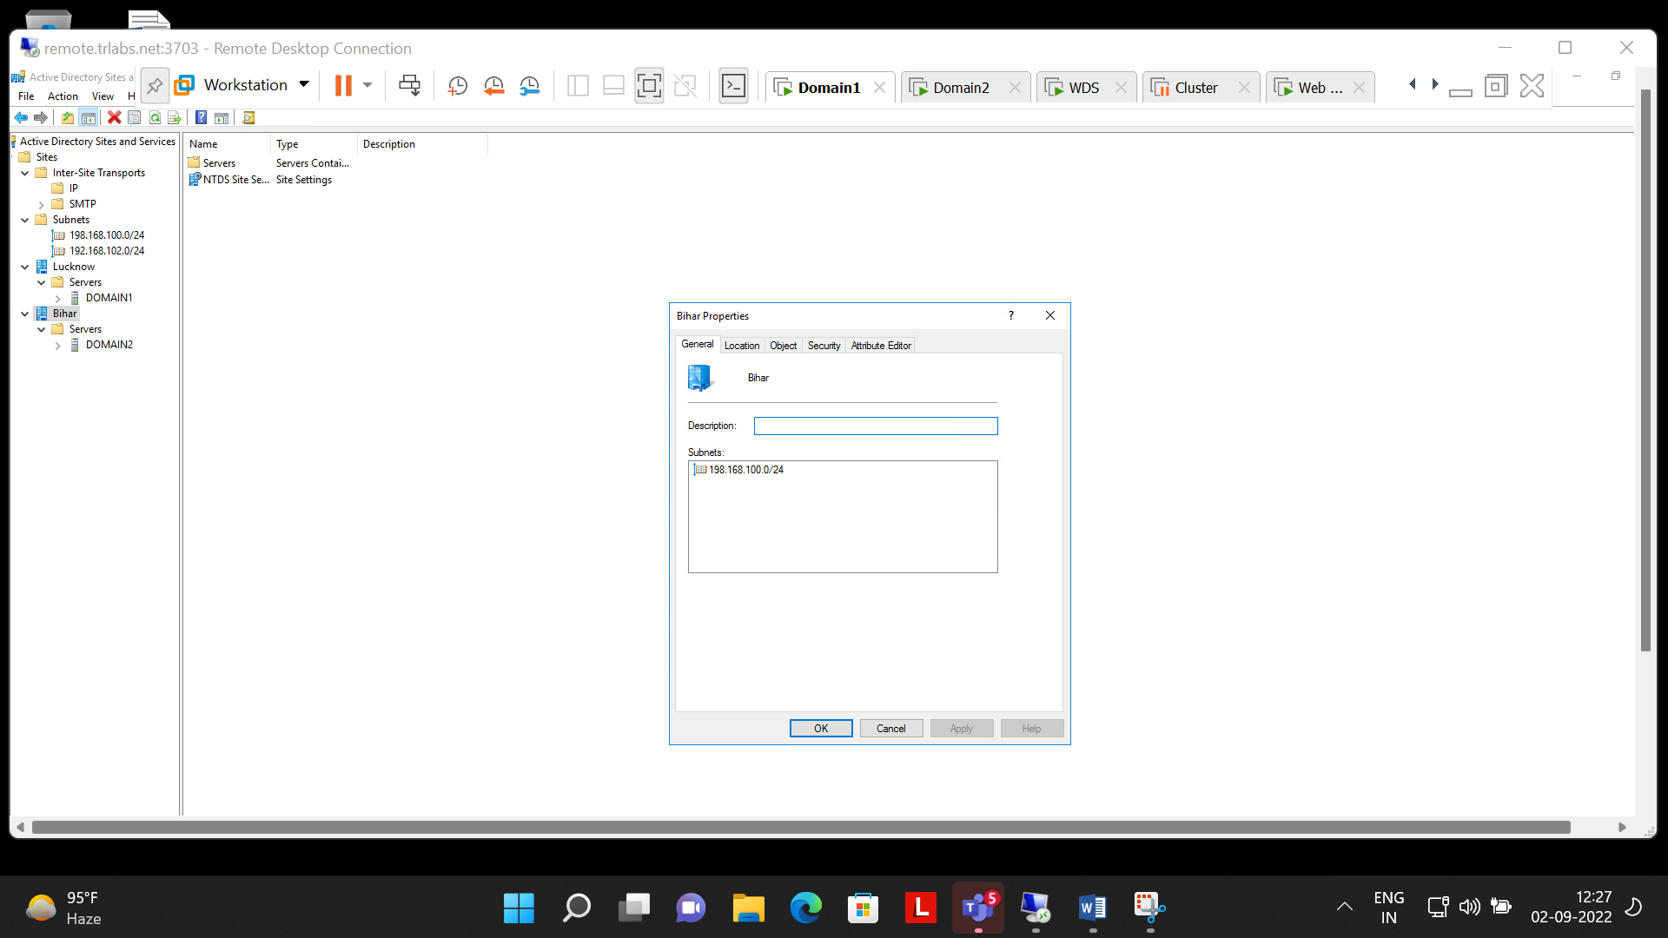

Step 2:- Created Both Subnets for (Bihar & Lucknow)

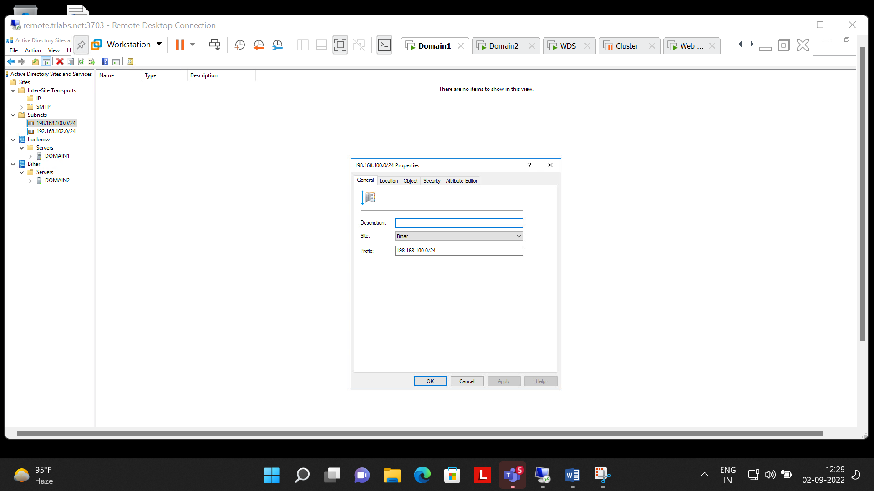

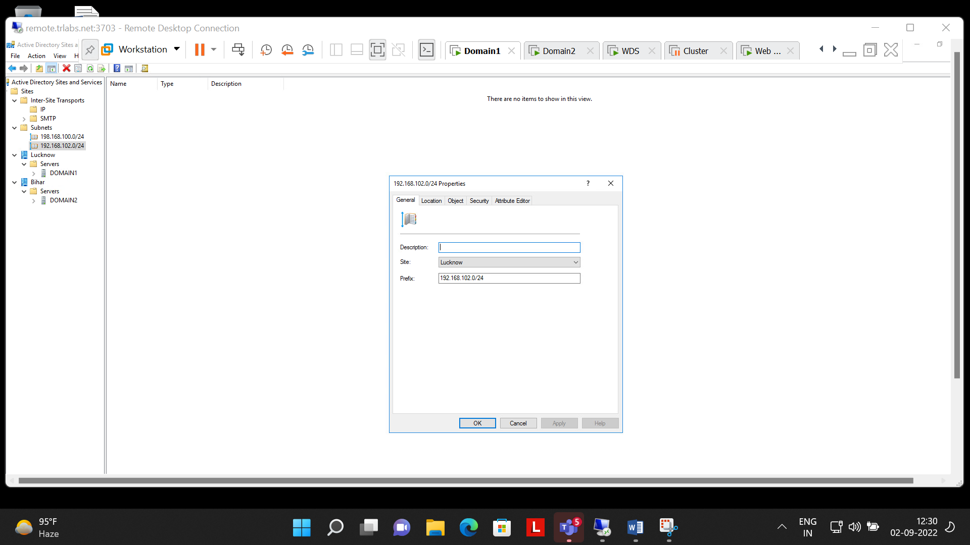

Step3:- Replication not available in working Hours

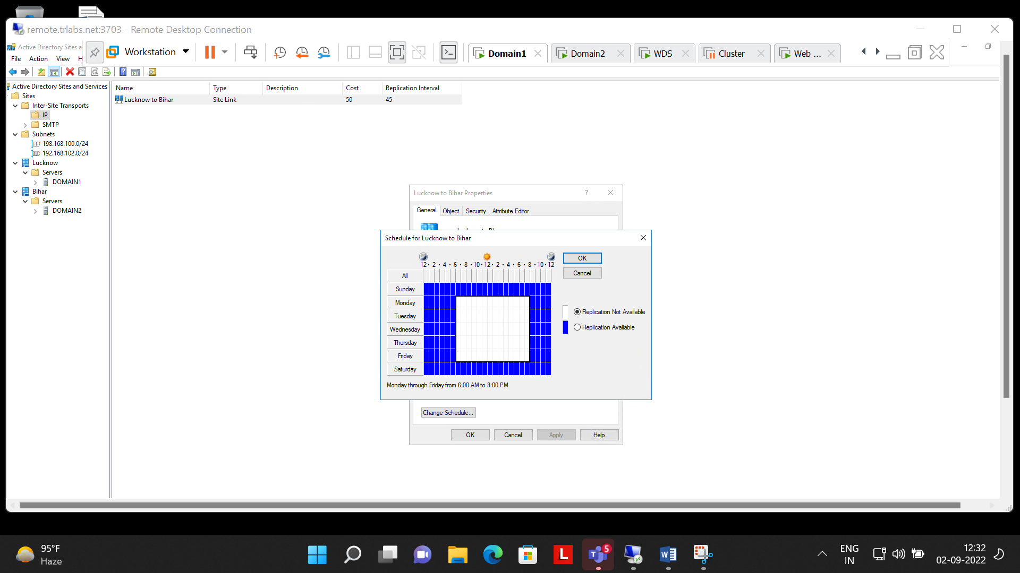

Step 4:- All the process are done and now its working

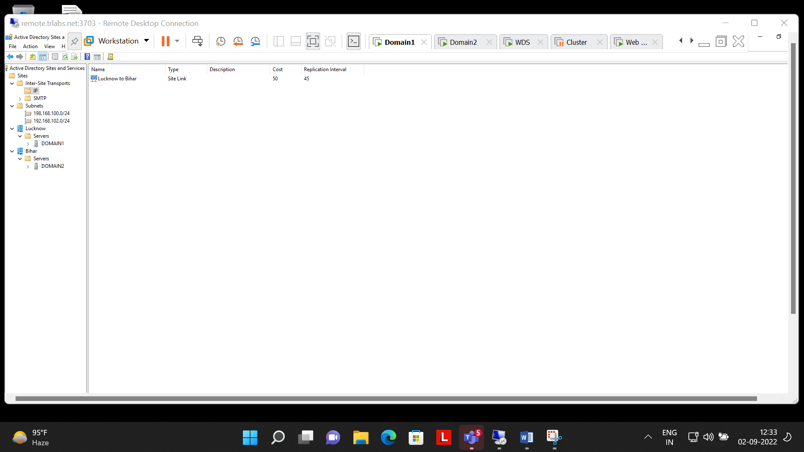

**Question Number 8 Successfully Completed**

**All Questions are completed**